**Assessment of the northern contingent of Atlantic Mackerel (*Scomber scombrus) in 2020***

Andrew Smith, Elisabeth Van Beveren,   
Linda Girard, Mélanie Boudreau, and Stéphane Plourde

Fisheries and Oceans Canada  
Institut Maurice-Lamontagne  
850, route de la Mer  
Mont-Joli, Québec  
G5H 3Z4

Foreword0

This series documents the scientific basis for the evaluation of aquatic resources and ecosystems in Canada. As such, it addresses the issues of the day in the time frames required and the documents it contains are not intended as definitive statements on the subjects addressed but rather as progress reports on ongoing investigations.

Published by :

Fisheries and Oceans Canada  
Canadian Science Advisory Secretariat  
200 Kent Street Ottawa ON K1A 0E6

<http://www.dfo-mpo.gc.ca/csas-sccs/>   
[csas-sccs@dfo-mpo.gc.ca](mailto:csas-sccs@dfo-mpo.gc.ca)

please recycle

© Her Majesty the Queen in Right of Canada, 2021  
ISSN 1919-5044

Correct citation for this publication:

Smith, A.D., Van Beveren, E., Girard, L., Boudreau, M., and Plourde, S. 2020. Assessment of the northern contingent of Atlantic Mackerel (Scomber scombrus) in 2020. DFO Can. Sci. Advis. Sec. Res. Doc. 2021/nnn. iv + 38 p.

Aussi disponible en français:

Smith, A.D., Van Beveren, E., Girard, L., Boudreau, M., et Plourde, S. 2020. Évaluation du contingent Nord du maquereau bleu (Scomber scombrus) en 2021. Secr. can. de consult. sci. du MPO. Doc. de rech. 2021/xxx

TABLE of contents

ABSTRACT iv

INTRODUCTION 1

METHODS 1

LANDINGS 1

COMMERCIAL SAMPLING 2

CATCH-AT-AGE 2

MATURITY-AT-AGE 2

BIOMASS INDEX 2

STOCK ASSESSMENT MODEL 3

ENVIRONMENTAL DRIVERS OF RECRUITMENT, CONDITION, AND CATCH DISTRIBUTION 3

RESULTS AND DISCUSSION 5

LANDINGS 5

CATCH-AT-AGE 5

BIOMASS INDEX 6

MODEL OUTPUT 7

MATURITY-AT-LENGTH 10

ENVIRONMENTAL DRIVERS OF RECRUITMENT, CONDITION, AND LANDINGS DISTRIBUTION 11

QUALITY OF THE ASSESSMENT 12

CONCLUSIONS AND ADVICE 12

ACKNOWLEDGMENTS 13

REFERENCES 13

SUPPLEMENTARY INFORMATIONS 18

TABLES 18

FIGURES 31

# ABSTRACT

The status of the northern contingent of the Atlantic mackerel (*Scomber scombrus* L.; henceforth mackerel) in the Northwest Atlantic (NWA) is assessed every two years using an age-structured stock assessment model that explicitly accounts for missing catch statistics from Canadian and American fleets. This document presents the data and methods used to calculate the main stock status indicators for mackerel that forms the advice given to Fisheries Management (FM) in the setting of quotas (i.e. Total Allowable Catch; TAC), potentially as part of a broader set of Harvest Control Rules (HCR). This document also provides a review of research pertaining to mackerel distribution and how changing environmental conditions influenced mackerel recruitment, condition and distribution of landings throughout the fishing season. This stock assessment indicates that in 2020, mackerel were still within the Critical Zone as per Canada’s Precautionary Approach (PA) framework and have been since 2011. While there was a slight increase in SSB from 2016 to 2018 due to the arrival of the 2015 year class into the fishery, mackerel numbers have actually decreased. Low biomass is accompanied by overexploitation, the loss of older individuals from the population, and in the last two years, historical low recruitment. Short term projections over three years indicate that there is a 48% chance of leaving the Critical Zone by 2021 under a TAC of 10 000 t. Even under the most restrictive exploitation scenarios (e.g. TAC = 0 t), there is only a 68% chance of leaving the Critical Zone by 2021.

# INTRODUCTION

This research document provides a description of the data, methods, and supporting analyses contributing to the stock assessment of the northern contingent of the Atlantic mackerel stock in the Northwest Atlantic (Northwest Atlantic Fisheries Organisation (NAFO) Subareas 2-5). This assessment is carried out every two years by Fisheries and Oceans Canada (DFO) at the Maurice Lamontagne Institute in Mont-Joli, Québec. To move towards an ecosystem approach to stock assessments, a review of the research pertaining to mackerel ecology was carried out to support new analyses linking mackerel condition and distribution to changes in their physical and biological environment. All results herein were peer reviewed between the x and x March 2021 and the main results were incorporated into the Science Advisory Report (DFO 2021a).

Mackerel stock status has been evaluated with a [censored-catch-at-age stock assessment model](https://github.com/iml-assess) (CCAM; Van Beveren et al. 2017a) since 2016 (DFO 2017, Doniol-Valcroze et al. 2019). The model uses both fisheries-independent (biomass index) and fisheries-dependent data (landings, catch-at-age, and other biological parameters and data) as input and can estimate both current and future stock status indices such as spawning stock biomass (SSB) and age-1 recruitment. The biomass index is derived from an annual egg survey (1979-2019) that covers the main mackerel spawning site, i.e. the southern Gulf of Saint-Lawrence (GSL). Fisheries-dependent data includes catch statistics and biological samples acquired from the commercial mackerel fishery. Environmental data and biological samples are also obtained through DFO’s annual research vessel surveys in conjunction with the Atlantic Zonal Monitoring Program (AZMP; DFO 2019a). Additional sources of data and knowledge were acquired by reviewing peer reviewed literature as well as through consultations and survey results carried out in collaboration with the commercial fishery, First Nations, and members of the mackerel Rebuilding Plan Working Group (RPWG).

The last full stock assessment took place in March, 2019 and provided FM with advice for the 2019 and 2020 fishing seasons (DFO 2020a; Smith et al., 2020). A Management Strategy Evaluation (MSE) framework was also peer-reviewed during the last assessment (DFO 2020b; Van Beveren et al., 2020) and was used to assist FM and other stakeholders in the RPWG in evaluating the optimal trade-offs of different HCRs under a variety of uncertainties to attain both conservation and fishery focussed objectives. The results of the last stock assessment indicated that, in 2018, mackerel had been in the Critical Zone since 2011 as defined by Canada’s Precautionary Approach (PA) framework. The low biomass was accompanied by overexploitation of the stock, historical low recruitment, and the loss of older mackerel from the population. Short-term projections over three years indicated that there was 48% chance of surpassing the Limit Reference Point (LRP) defining the threshold between Critical and Cautious Zones by 2021 if the TAC was set to 10 Kt. The model also indicated that if the TAC were set to 0 t, there was only a 68% chance of surpassing the LRP by 2021. Following the 2019 stock assessment, FM recommended a TAC of 8 Kt to the Minister of Fisheries, Oceans, and the Canadian Coast Guard. This recommendation was approved for the 2019 fishing season and rolled-over for the 2020 fishing season. A number of other HCRs have also been implemented by regional FMs and will be described briefly in sections below.

# METHODS

## LANDINGS

Commercial fisheries data for mackerel caught in Canada’s Exclusive Economic Zone (EEZ; NAFO Subareas 2-4) were acquired from the most recent ZIFF (Zonal Interchange File Format) files produced by DFO’s regional statistics bureaus for the years 1995-2018. Inconsistencies in landings data exist prior to 1995 due to the historic presence of foreign fishing vessels targeting mackerel, undocumented ship to ship sales, the allocation of quota to foreign vessels, and the chartering of foreign vessels by local stakeholders. To resolve these issues, we used commercial fisheries data for mackerel landings within Canada’s EEZ from the [Northwest Atlantic Fisheries Organisation landings database](https://www.nafo.int/Data/STATLANT) for the years 1960-1994 (Grégoire et al. 2000, 2014). At the time of this assessment, landings data for the 2017 and 2018 fishing seasons were still preliminary as landings data were still being compiled by the various DFO regions exploiting mackerel (i.e. Québec, Gulf, Maritimes, and Newfoundland regions; Figures 1 and S1).

Data from the U.S. commercial and recreational fisheries (1960-2017) were provided by the Northeast Fisheries Science Center (NEFSC). Due to the 2018-2019 U.S. government shutdowns, leading to the temporary closure of the National Oceanic and Atmospheric Administration (NOAA), U.S. catch statistics were also preliminary for 2017 and 2018.

## COMMERCIAL SAMPLING

Mackerel are monitored annually through DFO’s commercial port sampling program. Length measurements and biological samples are collected throughout Eastern Canada covering the entire fishing season to ensure adequate spatio-temporal coverage (Tables S5-6). Port samplers provide length frequency data (measured to the nearest 5 mm) and a subsample (two fish per length-class) are sent to the Maurice Lamontagne Institute in Mont-Joli Québec for further analyses. The measurements taken of these subsamples include: fork-length (± 1 mm), mass (± 0.1 g), sex, gonad mass, stage of development, and age via extraction and examination of otolith structure. The latter measure has been the subject of a comparison with NOAA’s stock assessment biologists (Grégoire et al. 2009b).

## CATCH-AT-AGE

Catch-at-age was formerly calculated using a Visual Basic program developed at the Maurice Lamontagne Institute in 2011-2012 based on methods and equations detailed in Gavaris and Gavaris (1983). This procedure was rewritten in the R programming language (R Core Team 2019) using the same equations, as well as procedures described by Ogle (2015). Briefly, to estimate catch-at-age and the corresponding weight-at-age, biological samples were grouped by year, quarter (aggregated in 3 month blocks), NAFO Division, and gear type to produce age-length-keys. Ages were then assigned to the corresponding unaged length frequency data as per methods described in Kimura (1977), Isermann and Knight (2005), and Ogle (2015). Individual weights were assigned to the length frequency data based on predicted weight-length relationships for each year and quarter. The merged biological sample and length frequency data were then weighted by the regional (NAFO division) and quarterly landings, as well as by gear type (grouped by selectivity category). Time, space, and gear specific information was then averaged to obtain the annual catch-at-age (numbers of individuals) and their corresponding mean lengths and weights. Annual catch weight-at-age (biomass), the product of catch-at-age and weight-at-age, was then compared to commercial landings to detect possible grouping or weighting errors. In the event that no length frequency data and/or biological data was available for a given region, quarter, or gear type, age-length-keys corresponding to data from adjacent regions, quarters, or similar gear types were used instead.

## MATURITY-AT-AGE

Maturity-at-age, that is the proportion of mature females at a given age, was calculated from commercial samples collected during spawning (June-July). Maturity ogives were also used to estimate maturity-at-length (L50) were formerly calculated using the *Logistic* and *Probit* functions in SAS (v. 9.3; SAS Institute Inc. 2011). These procedures were rewritten in R whereby logistic regressions using a logit link family function were subsequently calculated. L50 were then extracted from the fitted models and were bootstrapped over 999 iterations using the ‘modelr’ package in R to produce 95% confidence intervals (Wickham et al. 2019).

## BIOMASS INDEX

A relative index of mackerel SSB is calculated from data collected during an annual survey targeting mackerel eggs (1979-2019), from commercial mackerel samples from the southern GSL (4T), in June and July, from equations describing mackerel fecundity and egg incubation time, and from oceanographic data collected in conjunction with the AZMP surveys. The index is based on date and temperature corrected estimates of Daily and Total Egg Productions (DEP; TEP). A detailed description of the surveys and methods used to derive the biomass index are described by Girard (2000) and Grégoire et al. (2014). Briefly, the survey samples the ichthyoplankton of the top 50 m of the water column along 65 fixed stations using 61 cm Bongo nets with 333 μm mesh deployed for a minimum of 10 minutes while cruising at roughly 2.5 knots. Tows are double oblique but may be towyos at shallower stations (i.e. < 50 m). Filtered volume, sampled depth, and the mean temperature in the top 10 m of the water column are calculated at each station and for each Bongo net. Mackerel eggs are then classified and tallied by development stage. Stage 1 and 5 egg counts are summed and converted to density (N·m-2) for each station by first dividing the counts by the fractioned sample to obtain the sample count (N). Counts are then divided by the volume of filtered seawater (m-3), and then multiplying by the depth (m) of the water column sampled.

Uncorrected DEP per station was calculated by accounting for the incubation time of eggs and the mean temperature of the top ten metres of the water column at each station (T) following Lockwood et al.’s (1977) model. From these values, mean annual DEPs and their associated standard deviations were calculated.

The proportion of eggs spawned (*Si*) at the median dates of each survey were calculated via logistic models, using the nls() function in R (ref), that described the annual seasonal progression of a gonado-somatic-index (GSI). This index was calculated from biological samples (females in the southern GSL in June and July) obtained from the commercial fishery. These models also permitted the calculation of the extent and peak of the spawning activity each year which were used to check for inter-annual trends and to verify the validity of the survey sampling dates. The logistic regressions took the following form:

Where:

*i* = the year

*x* = the Julian day of year (median mission date),

and *y0, a, x0 and b are estimated model parameters.*

Annual Spawning stock biomass (SSB; i.e. the biomass index) (Saville 1977) were subsequently calculated as:

Where:

*i =* the year

*SA =* the surface area of the surveyed area (6.945 · 1010 m2)

*M =* the mean mass (g) of females from biological samples (southern GSL, June and July)

S = the proportion of eggs spawned at the median mission date

F = female fecundity (Pelletier 1986)

SR = Sex ratio

Ordinary kriging is used to interpolate a mean egg density for the entire area. A fitted logistic curve describing the evolution of a gonado-somatic index by day, and thus the duration of the spawning period, is then used to calculate the proportion of eggs spawned daily. The SSB index is subsequently calculated as a function of the mean daily egg production, the sampled area, the mean weight of a mature female during spawning for a given year, the proportion of eggs spawned at the median date of the egg survey, and the derived fecundity of females. From 2015 to 2018, the survey was carried out on board the CCGS Teleost (June 12th – June 20th), the Coriolis II (June 11th – June 23rd), the CCGS Teleost (June 10th – June 17th), and the Coriolis II (June 16th – June 24th). Methods for the sampling protocol and subsequent analyses to calculate various aspects of mackerel egg production and the resulting biomass index are described in detail in Doniol-Valcroze et al. (2019).

## STOCK ASSESSMENT MODEL

The previous mackerel assessment (NAFO subareas 3 and 4) took place in March, 2017. A new statistical catch-at-age population dynamics model was developed to assess stock status and to fully integrate the various sources of uncertainty, including the estimation of missing catches.

This censored statistical catch-at-age model was described in detail by Van Beveren et al. (2017b) and was developed using the Template Model Builder (TMB; Kristensen et al. 2016) package in R (R Core Team 2019). Model equations are provided in Tables S7-S8 and input data is plotted in Figures 1-3 and S4-S5. The model was denoted "censored” as it uses a new approach in which reported catches are explicitly considered biased, and are thus estimated to occur between a lower limit, corresponding to reported catches, and an upper limit. This upper limit for unreported catches have been informed, as far as possible, by the available information on the bait and recreational fishing industry, the order of magnitude of which has been confirmed by results from an online survey distributed among active mackerel harvesters in Eastern Canada (Van Beveren et al. 2017a). The survey was undertaken again in 2018 and the preliminary results concord with the previous survey. In correspondence with the Precautionary Approach (PA) (DFO 2009), the Limit Reference Point (LRP) and Upper Stock Reference (USR) are calculated from this model as 40% and 80% of SSBF40%, respectively (Spawners-Per-Recruit at F40% multiplied by the average recruitment over 1969-2018). All [data, model code](https://github.com/iml-assess), and scripts are available online.

Short-term projections were also performed as a basis for 2019 TAC advice. A Management Strategy Evaluation (MSE) was also developed, which provided both medium-term and long-term projections under various uncertainty scenarios (DFO 2018). The statistical framework of the MSE and the assessment is the same (with the exception of eq. 4.1 in Table S7 and the proportion mature data, see Van Beveren et al., DFO, Mont-Joli, Qc, pers. comm.), and the forecasting procedure is detailed within the former. For the projections presented within this document and the SAR, recruitment was projected towards the mean value (1969-2018) with a temporal autocorrelation of 0.9 (as in Core model 1 of the MSE, Van Beveren et al., DFO, Mont-Joli, Qc, pers. comm.).

## ENVIRONMENTAL DRIVERS OF RECRUITMENT, CONDITION, AND CATCH DISTRIBUTION

To test how mackerel recruitment, body condition, and catch distribution were influenced by the environment, we used several environmental variables and mackerel stock characteristics obtained from commercial landings and samples, CCAM model output, and from the AZMP (DFO 2019a). We hypothesized that mackerel recruitment and condition depend on food availability in their habitat. We used a number of biological and physical environmental variables (Table S12) to test whether they could explain the variability in mackerel recruitment and condition. Specifically, we used physical environmental variables related to food availability in space (*St. Lawrence Runoffs* - a proxy for primary productivity) and in time (*Last Ice* and *Spring Timing* – proxies for the beginning of the spring bloom; and finally, sea surface temperature (*SST*)). More direct biological data were also used as explanatory variables such as the timing, duration, and amplitude of the phytoplankton bloom, as well as abundance indices for zooplankton prey known to be important for various mackerel life stages (*Calanus glacialis, C. finmarchicus, C. hyperboreus, Pseudocalanus, Temora spp.*). Time series for the variables were obtained from the AZMP oceanographic surveys (DFO 2019a). To test these relationships, we used Generalized Additive Models (mgcv::gam; Wood 2008) to allow for nonlinear relationships.

Depending on the availability of data in the time series, we considered different time periods using different combinations of the above mentioned variables in our analyses (1985-2016 only the physical variables, 2001-2016 only physical variables and, 2001-2016 with both physical and biological variables). In the later time series, we hypothesized that food availability and abundance would be the main drivers of mackerel recruitment and condition.

Following this, we also investigated how mackerel distribution could change as a function of the environment and mackerel stock characteristics. Mackerel distribution had to be estimated indirectly through the commercial fisheries’ landings data. The availability of georeferenced landings data in this fishery is limited so we used the relative proportion of landings by NAFO Division as a proxy for mackerel distribution, provided we also had sufficient biological sample data to calculate condition (i.e.4T, 4R, 3K, and 3L). We assumed that harvesters that prosecute this fishery do so every year and that the percentage of landings data in each NAFO subarea represented the relative mackerel occurrence in that area. Licences issued for mackerel in Newfoundland increased substantially in the mid-1990s, all the while purse and tuck seiners, which dominate catches in that region, increased their efficiency (e.g. dual frequency echo sounders (mackerel have no swim bladder), hold capacity, horse-power, GPS, and telecommunications). To account for this change in fishing efficiency, a variable for fishing period was included in the analyses (1982-1999 and 2000-2017). We hypothesized that mackerel’s distribution around Newfoundland is constrained by SSB, water temperature, and mackerel energy reserves. We assumed that when taken together, these variables would describe the physical and biological conditions experienced by mackerel and explain the observed changes in mackerel seasonal migrations and distribution (% landings).

Ringuette et al. (2002) found evidence of a negative relationship between density-dependence and growth for mackerel. Density-dependence would imply that when SSB is large, there would be greater dispersal to locate food and avoid competition. Historic accounts and the primary literature associate the arrival of mackerel around Newfoundland with warmer water temperatures along its coast (Moores et al. 1975; Pinhorn 1976). Mackerel generally avoid water temperatures lower than 7°C (Olla and Bejda 1976) and as such much of the waters surrounding Newfoundland are only occasionally available as mackerel habitat, due to the influence of the cold Labrador current. We used body condition and zooplankton abundance to describe how available food was and how well mackerel acquired energy reserves in a given region. Biological variables for NAFO Divisions 4R3KL (Newfoundland) were only available from 2000-2016 via the AZMP. As before, GAMs were used to allow for non-linear relationships (P. Brosset 2018*,* DFO Mont-Joli, pers. Comm.).

# RESULTS AND DISCUSSION

The key indicators used as model inputs for this stock are total catch statistics, catch-at-age data, and the biomass index. Maturity-at-length, L50, is also used as advice as to the minimum size at which fish could be caught to ensure that 50% of the fish are given the opportunity to spawn at least once.

## LANDINGS

During the 1980s and 1990s, declared landings by Canadian vessels were relatively stable and averaged around 22 000 t per year. The number of mackerel fishing permits increased in the early 1990s as part of a second mackerel development plan (DFO 1990, 1993). From 2000 to 2010, landings averaged 40 498 t. Canadian landings reached a record high of 55 726 t in 2005 due to the marked increase in fishing effort by small and large seiners on both the East and West coasts of Newfoundland, and the presence of a very large 1999 year class (Patterson 2014). This was followed by a severe drop in landings, reaching a low of 4 272 t in 2015. From 2016 to 2018, preliminary landings were 8 050 t (TAC 8 000 t), 9 430 t (TAC 10 000 t), and 10 499 t (TAC 10 000 t), respectively. Values for missing catch due to discards, fish caught through bait licences, fish caught recreationally, and the proportion of Canadian spawned mackerel caught in the U.S. winter mackerel fishery are not currently known. True total removals of northern contingent fish are hence presumed to fall somewhere between two bounds (i.e., they are ‘censored’), established as 110% of the declared Canadian landings (lower bound, grey line in Figure 1) to which an unknown fraction of Canadian are added (see Doniol-Valcroze et al. 2019) as well as 25-50% of the US catch statistics. Catch data since 1960 for the entire NWA stock are presented in Figure S1. Landings occurring solely within Canada’s EEZ and split by country of origin, Canadian province, DFO region, and NAFO Division are presented in Tables S1-S4 and Figures 1, S1, and S2.

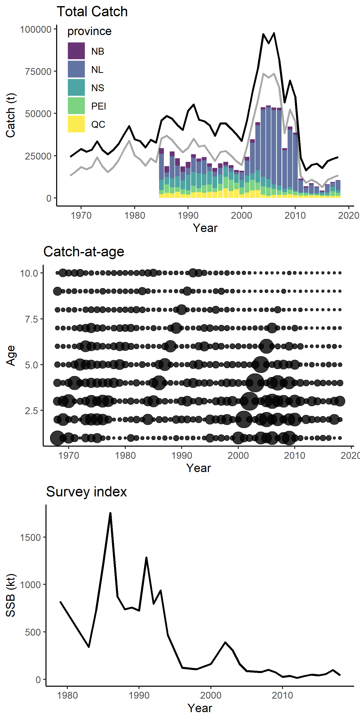

Figure 1. Canadian landings by province (barplot) with indication of the lower (grey) and upper (black) bound of the estimated total removals (including unaccounted-for catches of Canada and the US).

## CATCH-AT-AGE

The oldest mackerel on record from biological samples was 18 years old, but individuals over the age of 9 have been rare since the early 2000s, and individuals over the age of 6 have become increasingly rare since 2012, suggesting a collapse in the age structure of the stock. Fish under 3 years old dominated the fishery for the past 4 years, reflecting the entry of the 2015 cohort into the fishery (Figure 2). Similar trends in catch-at-age are observed in the southern contingent (NEFSC 2017).

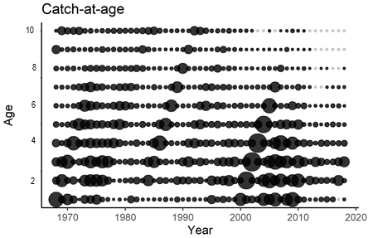

Figure 2. Catch-at-age (numbers). Grey dots indicate 0.

## BIOMASS INDEX

The biomass index calculated from the annual egg survey and from commercial samples in the southern GSL shows a variable yet clearly declining trend, reaching historic lows in recent years. The mean biomass index value since 1995 is approximately 12% of those from 1979-1994 (Figure 3). Furthermore, the area in which mackerel eggs are distributed has decreased (Grégoire et al. 2014) .



Figure 3. Relative biomass index derived from the egg survey.

The southern GSL has long been acknowledged as the main spawning site for northern contingent mackerel (Sette 1943; Arnold 1970). Ichthyoplankton surveys covering this area began at the beginning of the 20th century (Dannevig 1919) and have been repeated and improved over time (Maguire 1981; Ouellet 1987, Grégoire and Lafleur 2006; Grégoire and Faucher 2006). Many other ichthyoplankton surveys have also been carried out throughout mackerel’s distribution in the NWA. For example, surveys have been carried out in the Estuary and Gulf of Saint Lawrence (Kohler et al. 1974a, 1974b, 1975, 1976, 1977; Grégoire et al. 2008, 2009a), the Labrador and Newfoundland shelves as well as the inner bays of Newfoundland (Carter-Lynn 2000), and the Scotian Shelf (Sparks 1929; Grégoire et al. 2012; Bernier and Levesque 2000; Shackell and Frank 2000). These surveys suggested very limited spawning on the West coast of Newfoundland and the Scotian Shelf. The results also suggest that the low egg production measured in the Southern Gulf of Saint Lawrence since 2005 reflects a real decline in mackerel abundance.

The most recent exploratory mackerel egg survey took place on the northeast coast of Newfoundland following continued observations of juvenile mackerel in the area (Parsons and Hodder 1970). Three consecutive surveys in White Bay and Notre Dame Bay took place from June to August in 2015, followed by two more surveys in the same bays in July and August the following year. Two consecutive surveys in Trinity Bay, NL, were also undertaken in 2015 and 2016 during August and September as part of the annual DFO ichthyoplankton surveys targeting capelin but following nearly the same sampling protocols (however sampling over a greater portion of the water column up to depths of ~250 m; Shikon et al. 2019; Nakashima and Mowbray 2014). There were no mackerel eggs or larvae detected in either 2015 or 2016 across all three survey sites. These results are consistent with previous ichthyoplankton surveys describing species compositions in the region (Conception Bay, Bonavista Bay, Placentia Bay, and Trinity Bay; Carter-Lynn 2009), as well as known and predicted optimal spawning habitat preferences of mackerel (Mbaye et al. 2019*)*.

## MODEL OUTPUT

Residual plots and retrospective patterns are shown in Figures S5 and S6. Although there are no major issues, residuals for the egg survey index showed a linear tendency towards recent overestimation, possibly due to non-stationary processes that have not been considered in the current model formulation. Attempts to correct the bias by allowing for changes in fishery or survey selectivity (2 blocks reflecting pre- and post-2000) or natural mortality (Van Beveren et al., DFO, Mont-Joli, Qc, pers. comm.) did not significantly improve the pattern of survey residuals. Other causes could include temporal changes in fecundity, for which, however, no up to date data are available (Pelletier 1986).

The stock was estimated to have dropped below the USR in 2010 and below the LRP the year after (Figure 4A). In 2018, the SSB was estimated to be at 77% of the LRP, up from 59% in 2016 because of a relatively strong 2015 year class. The strength of this year class was important relative to more recent recruitment levels, but was however estimated to be significantly smaller relative to historically observed peaks (Figure 4C,D). For instance, the 2015 cohort (number of Age 1 fish) was estimated to be only 32% and 38% of the size of the 1982 and 1999 cohorts, respectively. Nonetheless, the 2015 cohort now dominates the landings as the population age structure is truncated (Figure 4B). Subsequent recruitment was estimated to be at all-time lows. A stock-recruitment relationship became clearly apparent, even when the model did not force such a relationship. Specifically, since biomass dropped below the USR in 2010, recruitment has on average been on the lower end (Figure 4D).

Fishing mortality rates (including estimated missing catch values) were estimated to remain above the reference level (Figure 4E,F). According to the consensus model, the estimated 2018 fishing mortality rate on fully exploited mackerel (ages 5 to 10) was 1.13 (exploitation rate of 68%). Although exploitation rate is usually given for fish that are fully recruited to the fishery, these mackerel do not compose a large fraction of the population anymore. The exploitation rate over all ages weighted by their numbers () was F = 0.44 (exploitation rate of 36%). Note that this exploitation rate is still relatively high, especially given that most fish are not fully targeted by the fishery yet. The 2018 exploitation rate on the dominant 2015 cohort was estimated to be 45%.

Projections were made over a three-year period to estimate the impact of different HCRs on the SSB. These HCRs were developed within the MSE framework by the RPWG. Although these rules determine a TAC dynamically (i.e., a TAC is applied annually according to the stock status, approximated by the egg survey index), they mostly result in a constant TAC within the short-term. The only exception is HCR 3, which allows the TAC to change up to 25% from one year to the next, depending on the relative change in the egg survey index. As such, testing these HCRs is currently similar to the use of traditional constant TACs in projections (e.g., previous mackerel assessment, Doniol-Valcroze et al. 2019), but parallels the ongoing MSE process.

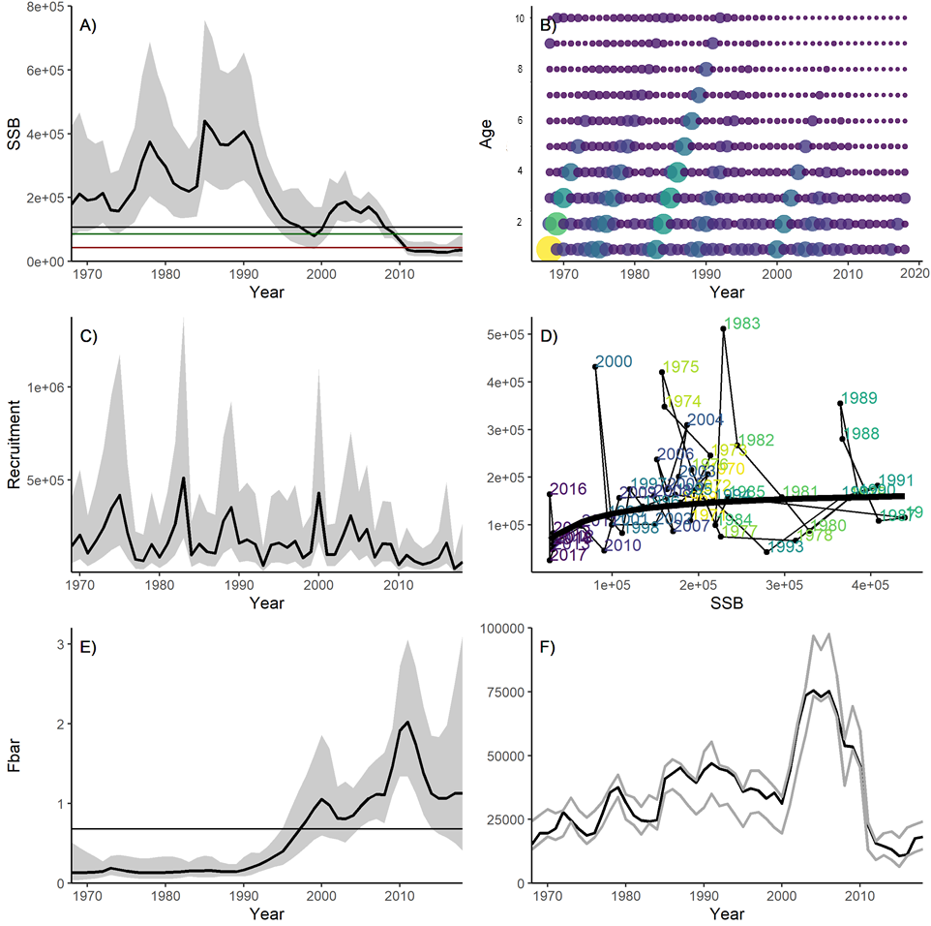

Figure 4. Model output: (A) Spawning Stock Biomass (t) with horizontal lines indicating SSBF40% (black), USR (green) and LRP (red), (B) abundance at age, (C) recruitment (numbers), (D) stock-recruitment, (E) fishing mortality (averaged over the fully selected age classes 5-10), (F) estimated catch (black) between the pre-determined bounds (grey).

In 2016, projections were made based on total removals, which included deterministic levels of unaccounted-for catches. We improved this projection approach by stochastically projecting unaccounted-for catches of both Canada and the US separately. The TAC generated by the HCR is added to these estimated catches to calculate total removals and the resulting next years’ stock biomass. During the assessment there was agreement that the Canadian missing catches had likely decreased due to the imposition of recent management measures, whereas the direction of possible US catches of northern contingent fish was unknown (although it was presumed the fraction remained at 25-50%). At the time, the US planned to increase their quota but it was unclear whether this would also materialise and if it would result in increased landings. The presumed missing catch patterns and their uncertainty for each missing catch component are plotted in Figure 5 and modelling details are provided in the MSE research document (Van Beveren et al., DFO, Mont-Joli, Qc, pers. comm.).

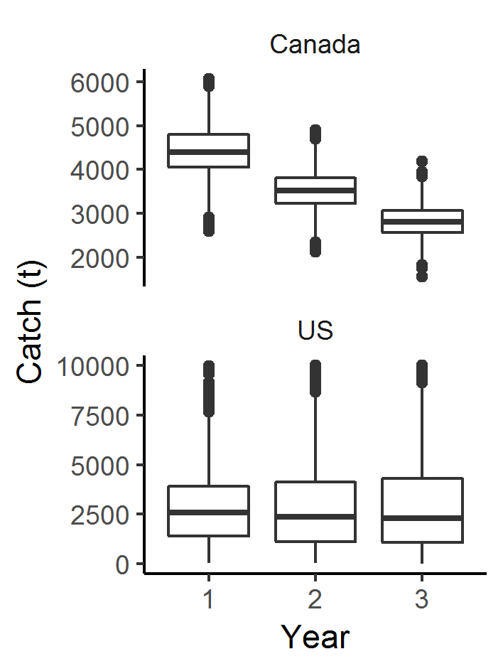

Figure 5. Boxplots of the assumed unaccounted-for catch over the next 3 years (2019-2021), for Canada (upper panel) and the US (lower panel) (generated with functions IEindep2019 and IEdep2550, CCAM package).

The projection table below was provided within the Stock Advisory Report. With increasing TACs from 0 to 10 000 t, the probability of exceeding the LRP by 2021 decreased from 68% to 48%, and the probability of stock growth from 2019 to 2021 decreased from 78% to 49%. Note that under the 2018 quota (10 000 t), the stock has a 51% chance to decline. Percentages of stock rebuilding (out of the Critical Zone) and growth do not extremely differ between the HCRs (despite a difference in floor TAC of 10 000 t) because of the large influence of unaccounted-for catch (e.g., the decrease in catches produced by lowering the TAC is not as large relative to the total landings) and the significant probability of not attaining the TAC during the next 3 years when fishing at the highest exploitation rates (e.g., HCR 10 and 11 are similar because 10 000 t might not be landed each year; Table 1).

Table 1. Three-year projections under different TACs (as determined by the Harvest Control Rules or HCRs, described in Van Beveren et al., DFO, Mont-Joli, Qc, unpublished data. Some HCRs (e.g. HCR 2, 4, 5 and 6) would result in (quasi-) identical TACs (median values) over the next three years and were therefore removed. The projections indicate the probability of reaching the Limit Reference Point (LRP) in 2020 and 2021 “Prob(SSB > LRP)” and the probability of growth occurring between 2019 and 2021 “Prob(SSB2021 > SSB2019)”. The beginning of year SSB is given relative to the LRP (median value) for 2020 and 2021. Projections were performed under the assumption that mackerel will also be caught outside of the TAC, by both the Canadian and US fleets (uncertainties represented by the 5th and 95th quantile taken over the three years). Figure 9 shows the assumed annual unaccounted-for catch distributions in detail.

| **HCR** | **TAC** | | | **Prob(SSB>LRP)** | | **Prob( *SSB2021>SSB2019*)** | **SSB/LRP** | | **Unaccounted-for catch** | | | |
| --- | --- | --- | --- | --- | --- | --- | --- | --- | --- | --- | --- | --- |
| 2019 | 2020 | 2021 | 2020 | 2021 | 2019→2021 | 2020 | 2021 | Canada | | US | |
| 5% | 95% | 5% | 95% |
| **3** | 9640 | 9334 | 8614 | 0.49 | 0.49 | 0.51 | 0.69 | 0.71 | 2425 | 4986 | 420 | 7282 |
| **4** | 0 | 0 | 0 | 0.60 | 0.68 | 0.78 | 0.98 | 1.16 | 2425 | 4986 | 420 | 7282 |
| **7** | 2000 | 2000 | 2000 | 0.58 | 0.65 | 0.72 | 0.92 | 1.06 | 2425 | 4986 | 420 | 7282 |
| **8** | 4000 | 4000 | 4000 | 0.55 | 0.60 | 0.65 | 0.86 | 0.96 | 2425 | 4986 | 420 | 7282 |
| **9** | 6000 | 6000 | 6000 | 0.53 | 0.56 | 0.59 | 0.79 | 0.86 | 2425 | 4986 | 420 | 7282 |
| **10** | 8000 | 8000 | 8000 | 0.51 | 0.52 | 0.53 | 0.74 | 0.76 | 2425 | 4986 | 420 | 7282 |
| **11** | 10000 | 10000 | 10000 | 0.49 | 0.48 | 0.49 | 0.67 | 0.68 | 2425 | 4986 | 420 | 7282 |

## MATURITY-AT-LENGTH

L50 has varied between 221-301 mm from 1974 to 2018 (Figure 6). In 2018, the time series mean was 267 mm while the five year mean (2013-2018) was 268 mm. The commercial samples used to calculate these values are primarily from the mackerel gillnet fishery in the southern GSL which coincides with mackerel spawning timing. Increasing the minimum commercial size should permit larger fish to spawn, however due to the large relative abundance of only a single year class in the population, the current effectiveness of this strategy is unknown.

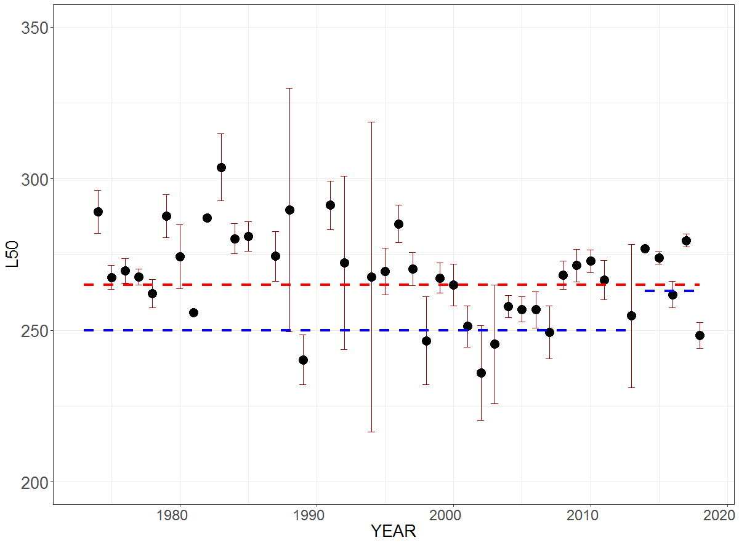

Figure 6. L50 with bootstrapped 95% confidence intervals (1968-2018).

## ENVIRONMENTAL DRIVERS OF RECRUITMENT, CONDITION, AND LANDINGS DISTRIBUTION

The Northwest Atlantic ecosystem is changing (DFO 2019a; Galbraith et al. 2019; Blais et al. 2019) and mackerel have strict habitat requirements and prey preferences. Mackerel recruitment, body condition, and other life history traits are not surprisingly also influenced by environmental conditions (Runge et al. 2001; Castonguay et al. 2008; Plourde et al. 2015). These results are further corroborated by observations made by mackerel researchers and harvesters alike who have attributed the variability in this species’ seasonal migrations and distribution to changes in water temperature (Templeman and Fleming 1953; Pinhorn 1976). Together, these observations and analyses suggest that the environment is a key driver in many aspects of mackerel life history (Trenkel et al. 2014).

We found that variation in mackerel recruitment and condition could be explained by environmental variables related to the availability and quality of food resources. The explicative power of all the models improved substantially when biological variables were included as independent variables. Taken together, these results show that when recruitment is low, as has been observed recently, it may be due, in part, to a mismatch between the temporal overlap of the emergence of mackerel larvae and the availability and quality of their food. Similarly, when the gain in adult condition is lower in a given area over the summer, it may be because they are feeding in a relatively poor feeding area.

Model fit for mackerel recruitment (deviance explained), improved from 57% to 82% when considering the biological variables. Specifically, recruitment was greater when mean SST was lower (May-August), when spring timing was early, when *C. finmarchicus* abundance was high, and when *Pseudocalanus sp.* phenology was early. Together these results indicate that recent low mackerel recruitment may be due to a mismatch between mackerel spawning and the availability of their prey (Figure S7, Tables S13-S14).

In the absence of biological variables, mackerel gain in condition was difficult to explain regardless of the time period or the area analysed. When biological variables were included, model fit for gain in condition in 4R went from non-significant to 80% deviance explained. Similarly, model fit for mackerel gain in condition in 4T improved from 62% to 83% with the inclusion of biological variables. The results suggest that when phytoplankton and zooplankton abundances in 4R were larger and synchronised with mackerel spawning, then mackerel had a greater gain in condition between June and September. As with 4R, mackerel caught in 4T had a greater gain in condition with the earlier development of phytoplankton and *C. finmarchicus*. Thus, when phytoplankton and zooplankton blooms occurred at the beginning of summer, coinciding with the end of mackerel migration to and spawning within the southern GSL, food may have been more available and resulted in a greater gain in condition over the summer in 4T (Figure S7, Tables S13-S14).

Our results show that the proportion of landings in the GSL (4T and 4R) relative to northeastern Newfoundland (3K and 3L) depends on stock size (SSB), relative gain in condition, as well as environmental variables related to food availability. When SSB was large and condition in 4T was poor, a greater proportion of landings were observed in 4R relative to 4T. A greater proportion of landings in 3K and 3L relative to 4R was also observed when SSB was large (i.e. greater competition for resources) and there was poor body condition in 4R. Increased landings in 3K and 3L also coincided with years when there were greater abundances of *C. finmarchicus* in those areas. While the effect of SST on mackerel landings was not detected, *C. finmarchicus* is associated with warmer waters and thus water temperature might limit food availability in 3KL in colder years as well as mackerel’s access to that resource due to their strict thermal tolerances. These results are similar to analyses relating the Northeast Atlantic mackerel distribution and their recent occurrences around Iceland to changes in SSB, SST, and food availability (Nikolioudakis et al. 2019). Together, these results tell us that increased landings of mackerel in a given area following spawning (mid-July to early November) can be explained by greater food availability (abundance of food and mackerel condition) in that region relative to another (Figure S7, Tables S13-S14).

# QUALITY OF THE ASSESSMENT

Many of the key uncertainties within the data highlighted in previous assessments, as well as our knowledge of stock dynamics, have in large part been accounted for through the use of the current stock assessment model. Although uncertainties remain, stock status trends across different data sources are consistent and large enough to lend confidence as to stock status. The trends and derived conclusions are also consistent when different stock assessment models and sensitivity analyses are performed. However, the proportion of northern contingent mackerel caught in the U.S. mackerel fishery is not known but is yet likely to be high. The lack of catch data from the bait and recreational fisheries, missing or incomplete logbooks, the use of less detailed purchase slips as opposed to logbooks, the different levels of dockside monitoring among regions, and the lack of observer-at-sea coverage for this species are all important issues that should be addressed to improve advice.

# CONCLUSIONS AND ADVICE

The northern contingent of Northwest Atlantic mackerel is currently in the Critical Zone as defined by DFO’s PA framework (DFO 2009) and has been since 2011. According to the PA framework, while a stock is in the Critical Zone, management actionsmust “*promote stock growth out of the Critical Zone (i.e. grow the stock beyond the LRP) by ensuring removals from all fishing sources are kept to the lowest possible level until the stock has cleared this zone. There should be no tolerance for preventable decline. This objective remains the same whether the stock is declining, stable or increasing”.* Stock projections provided in Table 1 will allow decision makers to weight the trade-offs between stock size and different HCRs over a period of three years. The quality of advice could be improved by ensuring that all mackerel fisheries accurately account for all removals (Van Beveren et al., DFO, Mont-Joli, Qc, pers. comm.*)*.

These stock projections must also be considered within the context of the species’ biology and the ecosystem in which it lives. Stock productivity is currently low due to changes in the environment and the collapsed age structure of the population. It should be kept in mind that the collapse in age structure is due solely to overfishing. As there is a stock-recruit relationship, the currently high fishing mortality and low recruitment may impede the stock’s ability to renew itself and grow under current HCRs. Variation in mackerel recruitment, how well individuals grow during the summer season, and their distributions, are likely to continue to vary with respect to the relative availability of food in a given region and other environmental features such as water temperature.

# ACKNOWLEDGMENTS

The stock assessment of mackerel requires the collaboration and coordination of people and resources from across Ontario, Québec, New Brunswick, Prince Edward Island, Nova Scotia, Newfoundland & Labrador, and the United States of America. Public servants, private citizens, and other stakeholders have all contributed to the process and it would be impossible to name them all. Nonetheless we would like to thank Dr. Sean Cox (Simon Fraser University) and Dr. Fan Zhang (Memorial University of Newfoundland) who served as external reviewers for this stock assessment. We would also like to acknowledge the contributions made by the Canadian Coast Guard and the crew of the CCGS Teleost, Reformar and the crew of the Coriolis II, everyone who participated in and contributed to the peer review of this stock assessment including Mathieu Désgagnés who served as chair, colleagues from the Maritimes, Gulf, and Newfoundland regions who provided data and code, the technical support staff at the Maurice Lamontagne Institute, the network of DFO port samplers, the statistics division of DFO, members of the Atlantic Mackerel Rebuilding Plan Working Group and the Atlantic Mackerel Advisory Committee, national and regional fisheries managers, our colleagues at the NEFSC and NAFO, and finally to all the stakeholders who provided their knowledge, historical context, or samples.

# REFERENCES

Arnold, P.W. 1970. Spawning and aspects of the early life history of the Atlantic mackerel (*Scomber scombrus L*.) in the Gulf of St. Lawrence. B. Sc. Thesis. Acadia University, Wolfville, Nova Scotia. 73 pp.

Blais, M., Galbraith, P.S., Plourde, S., Scarratt, M., Devine, L. and Lehoux, C. 2019. [Chemical and Biological Oceanographic Conditions in the Estuary and Gulf of St. Lawrence during 2018](http://www.dfo-mpo.gc.ca/csas-sccs/Publications/ResDocs-DocRech/2019/2019_059-eng.html). DFO Can. Sci. Advis. Sec. Res. Doc. 2019/059. iv + 64 pp.

Bernier, D., and Lévesque, C. 2000. Preliminary results of the mackerel (*Scomber scombrus L*.) egg survey conducted in 1999 in St. Margarets Bay, Nova Scotia. In [The Atlantic mackerel (*Scomber scombrus L*.) of NAFO Subareas 2 to 6](http://www.dfo-mpo.gc.ca/csas-sccs/publications/resdocs-docrech/2000/2000_021-eng.htm). Chapter 9. Edited by F. Grégoire. DFO Can. Sci. Advis. Sec. Res. Doc. 2000/021. pp. 305-322

Carter-Lynn, K. 2009. Temporal and spatial variation in community diversity, richness and abundance of ichthyoplankton in coastal Newfoundland over two decades. St. John's, Nfld: Dept. of Biology, Memorial University of Newfoundland.

Castonguay, M. Plourde, S., Robert, D., Runge, J.A., and Fortier, L. 2008. Copepod production drives recruitment in a marine fish. Can. J. Fish. Aquat. Sci. 2008, 65(8): 1528-1531.

Dannevig, A. 1919. Canadian fish-egg and larvae. In Hjort (ed.) Canadian Fisheries Expedition 1914-1915: Investigations in the Gulf of St. Lawrence and Atlantic waters of Canada. Department of the Naval Service. Kings Printer, Ottawa, Ontario. 495 pp.

DFO. 1990. Underutilized Species Workshop Yarmouth, Nova Scotia January 17-18,1990 Sponsored by Department of Fisheries and Oceans Scotia-Fundy Region Halifax Nova Scotia Proceedings

DFO. 1993. Offshore/Inshore Fisheries Development, Atlantic Mackerel. Communications Directorate, Department of Fisheries and Oceans, Ottawa, Canada

DFO. 2009. [Sustainable Fisheries Framework (SFF) : A Fishery Decision-Making Framework Incorporating the Precautionary Approach. Guidance for the Development of Rebuilding Plans under the Precautionary Approach Framework: Growing Stocks out of the Critical Zone](https://www.dfo-mpo.gc.ca/reports-rapports/regs/sff-cpd/precautionary-precaution-eng.htm).

DFO. 2017. [Assessment of the Atlantic Mackerel Stock for the Northwest Atlantic (Subareas 3 and 4) in 2016](http://www.dfo-mpo.gc.ca/csas-sccs/Publications/SAR-AS/2017/2017_034-eng.html). DFO Can. Sci. Advis. Sec. Sci. Advis. Rep. 2017/034.

DFO. 2018. [Update of the projections for Atlantic mackerel (subareas 3 and 4)](http://www.dfo-mpo.gc.ca/csas-sccs/Publications/ScR-RS/2018/2018_024-eng.html). DFO Can. Sci. Adv. Sec. Sci. Rep. 2018/024.

DFO. 2019a. [Oceanographic Conditions in the Atlantic Zone in 2018](http://www.dfo-mpo.gc.ca/csas-sccs/Publications/SAR-AS/2019/2019_034-eng.html). DFO Can. Sci. Advis. Sec. Sci. Advis. Rep. 2019/034.

DFO. 2019b. [Assessment of the Atlantic Mackerel stock for the Northwest Atlantic (Subareas 3 and 4) in 2018](http://www.dfo-mpo.gc.ca/csas-sccs/Publications/SAR-AS/2019/2019_035-eng.html). DFO Can. Sci. Advis. Sec. Sci. Advis. Rep. 2019/035

Doniol-Valcroze, T., Van Beveren, E., Légaré, B., Girard, L., and Castonguay, M. 2019. [Atlantic mackerel (*Scomber scombrus L*.) in NAFO Subareas 3 and 4 in 2016](http://www.dfo-mpo.gc.ca/csas-sccs/Publications/ResDocs-DocRech/2018/2018_062-eng.html). DFO Can. Sci. Advis. Sec. Res. Doc. 2018/062. v + 51 p.

Galbraith, P.S., Chassé, J., Caverhill, C., Nicot, P., Gilbert, D., Lefaivre, D. and Lafleur, C. 2019. [Physical Oceanographic Conditions in the Gulf of St. Lawrence during 2018](http://www.dfo-mpo.gc.ca/csas-sccs/Publications/ResDocs-DocRech/2019/2019_046-eng.html). DFO Can. Sci. Advis. Sec. Res. Doc. 2019/046. iv + 79 p

Gavaris, S., and Gavaris, C.A. 1983. Estimation of catch at age and its variance for groundfish stocks in the Newfoundland regions. in Doubleday, W.G., and Rivard, D. (Editors). Sampling Commercial Catches of Marine Fish and Invertebrates. Can. Spec. Pub. Fish. Aq. Sci. 66.

Girard, L. 2000. Identification of mackerel (*Scomber scombrus* L.) eggs sampled during abundance surveys in the southern Gulf of St. Lawrence. Chapter 4. *in* Grégoire, F. (Editor). [The Atlantic mackerel (*Scomber scombrus* L.) of NAFO Subareas 2 to 6](http://www.dfo-mpo.gc.ca/csas-sccs/publications/resdocs-docrech/2000/2000_021-eng.htm). DFO Can. Sci. Advis. Sec. Res. Doc. 2000/021. Pp. 119-138.

Grégoire, F., and Faucher, S. 2006. [Distribution and abundance of the Atlantic mackerel (*Scomber scombrus L*.) eggs for the ichthyoplankton surveys conducted in the sourthern Gulf of St. Lawrence between 1976 to 1979](http://www.dfo-mpo.gc.ca/csas-sccs/publications/resdocs-docrech/2006/2006_099-eng.htm). DFO Can. Sci. Advis. Sec. Res. Doc. 2006/099.

Grégoire, F., and Lafleur, C. 2006. [Distribution and abundance of the Atlantic mackerel (*Scomber scombrus L*.) eggs for the ichthyoplankton surveys conducted in the sourthern Gulf of St. Lawrence between 1965 to 1975](http://www.dfo-mpo.gc.ca/csas-sccs/publications/resdocs-docrech/2006/2006_098-eng.htm). DFO Can. Sci. Advis. Sec. Res. Doc. 2006/098.

Grégoire, F., Bernier, D., and Hurtubise, S. 2000. Update (1960-1994) of the Atlantic mackerel (*Scomber scombrus L*.) catches made by foreign vessels in NAFO subareas 3 to 6. Chapter 2. *in* Grégoire, F. (Editor). [The Atlantic mackerel (*Scomber scombrus* L.) of NAFO Subareas 2 to 6](http://www.dfo-mpo.gc.ca/csas-sccs/publications/resdocs-docrech/2000/2000_021-eng.htm). DFO Can. Sci. Advis. Sec. Res. Doc. 2000/021. pp. 31-50.

Grégoire, F., Barry, W., Barry, J., Gregan, O., Lévesque, C., Beaulieu, J.-L., and Gendron, M.-H. 2008. [Assessment of the Atlantic mackerel (*Scomber scombrus L*.) spawning stock biomass from the data of the ichthyoplankton surveys made on the west coast of Newfoundland in 2004 and 2005](http://www.dfo-mpo.gc.ca/csas-sccs/publications/resdocs-docrech/2008/2008_039-eng.htm). DFO Can. Sci. Advis. Sec. Res. Doc. 2008/039.

Grégoire, F., Barry, W., Barry, J.-J., Barry, J., Lévesque, C., Beaulieu, J.-L., and Gendron, M.-H. 2009a. Calculation of the Atlantic Mackerel (*Scomber scombrus L.*) Spawning Biomass from the Ichthyoplankton Surveys Conducted on the West Coast of Newfoundland in July 2007 and 2008. Transboundary Resources Assessment Committee (TRAC). Ref. Doc. 2009/09.

Grégoire, F., Shepherd, N., and Sutherland, S. J. 2009b. Inter-laboratory ageing exchange of Atlantic mackerel (*Scomber scombrus*) otoliths for the 2009 Transboundary Resources Assessment Committee. Transboundary Resources Assessment Committee (TRAC). Ref. Doc. 2009/008. 9 pp.

Grégoire, F., Beaulieu, J.-L., Gendron, M.-H., and LeBlanc, D. 2012. [Results of the Atlantic mackerel (*Scomber scombrus L.)* egg survey conducted on the Scotian Shelf and Newfoundland’s South Coast in 2009](http://www.dfo-mpo.gc.ca/csas-sccs/Publications/ResDocs-DocRech/2012/2012_127-eng.html). DFO Can. Sci. Advis. Sec. Res. Doc. 2012/127.

Grégoire, F., Girard, L., and Boudreau, M. 2014. [La pêche au maquereau bleu (*Scomber scombrus* L.) dans les sous-régions 3 et 4 de l’OPANO en 2013](http://www.dfo-mpo.gc.ca/csas-sccs/publications/resdocs-docrech/2014/2014_077-fra.html). Secr. can. de consult. sci. du MPO. Doc. de rech. 2014/077. vi + 119 p.

Isermann, D.A. and Knight, C.T. 2005. A computer program for age-length keys incorporating age assignment to individual fish. North Amer. J. Fish. Manag. 25:11531160.

Kimura, D.K. 1977. Statistical assessment of the age-length key. J. Fish. Res. Board Can., 34:317324.

Kohler, A.C., Faber, D.J. and McFarlane, N.J.. 1974a. Eggs, larvae and juveniles of fishes from plankton collections in the Gulf of St. Lawrence during 1965, 1966 and 1967. Fish. Res. Board Can. Tech. Rep. No. 285, 164 pp.

Kohler, A. C., Faber, D.J.and McFarlane, N.J. 1974b. Eggs, larvae and juveniles of fishes from plankton collections in the Gulf of St. Lawrence during 1968. Fish. Mar. Serv. Res. Dev. Tech. Rep. 490, 105 pp.

Kohler, A. C., Faber, D.J.and McFarlane, N.J. 1975. Eggs, larvae and juveniles of fishes from plankton collections in the Gulf of St. Lawrence during 1969. Fish. Mar. Serv. Res. Dev. Tech. Rep. 521, 154 pp.

Kohler, A. C., Faber, D.J.and McFarlane, N.J. 1976. Eggs, larvae and juveniles of fishes from plankton collections in the Gulf of St. Lawrence during 1970-1971. Fish. Mar. Serv. Res. Dev. Tech. Rep. 645, 139 pp.

Kohler, A. C., Faber, D.J.and McFarlane, N.J. 1977. Eggs, larvae and juveniles of fishes from plankton collections in the Gulf of St. Lawrence during 1972 to 1975. Fish. Mar. Serv. Tech. Rep. 747, 180 pp.

Kristensen, K., Nielsen, A., Berg, C.W., Skaug, H., and Bell, B.M. 2016. TMP: Automatic Differentiation and Laplace Approximation. J. Statistical Software. 70(5). doi: 10.18637/jss.v070.i05

Lockwood, S. J., Nichols, J. H., and Coombs, S. H. 1977. The development rates of mackerel (*Scomber scombrus* L.) eggs over a range of temperatures. ICES CM 1977/J: 13. 13 pp.

Maguire, J.-J. 1981. Maturité, fécondité, ponte et évaluation de la taille reproducteur du maquereau atlantique (*Scomber scombrus*) dans le Golfe du Saint-Laurent. Thèse de M. Sc. Université Laval, Québec.

Mbaye, B., Doniol-Valcroze, T., Brosset, P., Castonguay, M. Van Beveren, E., Smith, A., Lehoux, C., Brickman, D., Wang, Z., and Plourde, S. 2019. Modelling Atlantic mackerel spawning habitat suitability and its future distribution in the Northwest Atlantic. Fish. Oceanogr. 10.1111/fog.12456.

Moores, J.A., Winters, G.H., and Parsons, L.S. 1975. Migrations and biological characteristics of Atlantic mackerel (*Scomber scombrus*) occurring in Newfoundland waters. J. Fish. Res. Board Can. 32:1347-1357.

Nakashima, B.S., and Mowbray, F.K. 2014. [Capelin (*Mallotus villosus*) recruitment indices in NAFO Division 3KL](http://www.dfo-mpo.gc.ca/csas-sccs/publications/resdocs-docrech/2013/2013_091-eng.html). DFO Can. Sci. Advis. Sec. Res. Doc. 2013/091 v + 27 p.

Nikolioudakis, N., Skaug, H.J., Olafsdottir, A.H., Jansen, T., Jacobsen, J.A., and Enberg, K. 2019. Drivers of the summer-distribution of Northeast Atlantic mackerel (*Scomber scombrus*) in the Nordic Seas from 2011 to 2017; a Bayesian hierarchical modelling approach. ICES J. Mar. Sci. 76(2): 530-548.

Northeast Fisheries Science Center (NEFSC). 2017. 64th Northeast Regional Stock Assessment Workshop (64th SAW) Assessment Report. Northeast Fish Sci. Cent. Ref. Doc. 18-03.

Ogle, D.H. 2015. Introductory Fisheries Analyses with R. Chapman and Hall/CRC. USA.

Olla, B.L., and Bejda, A.J. 1976. Swimming speeds of Atlantic mackerel, *Scomber scombrus*, under laboratory conditions: relation to capture by trawling. ICNAF Res.Doc. 76/XII/143.

Ouellet, P. 1987. [Mackerel (*Scomber scombrus*) egg abundance in the southern Gulf of St. Lawrence from 1979 to 1986, and the use of the estimate for stock assessment](http://www.dfo-mpo.gc.ca/csas-sccs/publications/resdocs-docrech/1987/1987_062-eng.html). CAFSAC Res. Doc. 87/62, 40 p.

Parsons, L.S., and Hodder, V.M. 1970. Occurrence of juvenile and spawning Atlantic mackerel in southeastern Newfoundland coastal waters.. J. Fish. Res. Board Can. 27: 2097-2100.

Patterson, B. 2014. Study of the small pelagic fisheries for Atlantic herring and Atlantic mackerel on the west coast of Newfoundland (NAFO Division 4R). Project Report. Memorial University of Newfoundland, St. John’s, Newfoundland.

Pelletier, L. 1986. Fécondité du maquereau bleu, *Scomber scombrus* L., du golfe du Saint-Laurent. Rapp. tech. can. sci. halieut. aquat. 1467: v + 37 p.

Pinhorn, A.T. [ed.] 1976. Living marine resources of Newfoundland—Labrador :  
status and potential. Bull. Fish. Res. Board Can. 194: 64 p.

Plourde, S., Grégoire, F., Lehoux, C., Galbraith, P., Castonguay, M., and Ringuette, M. 2015. Effect of environmental variability on body condition and recruitment success of Atlantic mackerel (*Scomber scombrus* L.) in the Gulf of St. Lawrence. Fish. Oceanogr. 24: 347-363.

R Core Team. 2019. R: A Language and Environment for Statistical Computing. R Foundation for Statistical Computing, Vienna.

Ringuette, M., Castonguay, M., Runge, J.A., and Grégoire, F. 2002. Atlantic mackerel (*Scomber scombrus*) recruitment fluctuations in relation to copepod production and juvenile growth. Can. J. Fish. Aquat. Sci. 59: 646-656.

Runge, J.A., Castonguay, M., De Lafontaine, Y., Ringuette, M., and Beaulieu J.-L. 2001. Covariation in climate, zooplankton biomass and mackerel recruitment in the southern Gulf of St Lawrence. Fish. Oceanogr. 8. 139-149. 10.1046/j.1365-2419.1999.00095.x.

SAS Institute Inc. 2011. Base SAS® 9.3 Procedures Guide. Cary, NC: SAS Institute Inc.

Sette, O.E. 1943. Biology of the Atlantic mackerel (*Scomber scombrus* L.) of North America. Part 1. Early history. U.S. Fish. Wildlife Service. Fish. Bull. 38(50): 149-237.

Shackell, N.L. and Frank, K.T. 2000. Larval fish diversity on the Scotian Shelf. Can. J. Fish. Aquat. Sci. Vol. 57. 1747-1760.

Shikon, V., Pepin, P., Schneider, D.C., Castonguay, M., and Robert, D. 2019. Spatiotemporal variability in Newfoundland capelin (*Mallotus villosus*) larval abundance and growth: Implications for recruitment. Fish. Res. 218: 237-245.

Sparks, M. I. 1929. The Spawning and Development of Mackerel on the Outer Coast of Nova Scotia. Can. Biol. Fish. No. 28.

Templeman, W. and Fleming, A.M. 1953. Long Term Changes in Hydrographic Conditions and Corresponding Changes in the Abundance of Marine Animals. ICNAF Annu. Proc. Vol 3: 79-86.

Trenkel, V.M., Huse, G., MacKenzie, B.R., Álvarez, P., Arrizabalaga, H., Castonguay, M., Goñi, N., Grégoire, F., Hátún, H., Jansen, T., Jacobsen, J.A., Lehodey, P., Lutcavage, M., Mariani, P., Melvin, G.D., Neilson, J.D., Nøttestad, L., Oskarsson, G.J., Payne, M.R., Richardson, D.E., Senina, I., and Speirs, D.C. 2014. Comparative ecology of widely distributed pelagic fish species in the North Atlantic: implications for modelling climate and fisheries impacts. Progress in Oceanography. 129: 219-243.

Van Beveren, E., Duplisea, D., Castonguay, M., Doniol-Valcroze, T., Plourde, S., and Cadigan, N. 2017a. How catch underreporting can bias stock assessment of and advice for northwest Atlantic mackerel and a possible resolution using censored catch. Fish. Res. 194. 146-154. 10.1016/j.fishres.2017.05.015.

Van Beveren, E., Castonguay, M., Doniol-Valcroze, T., and Duplisea, D. 2017b. [Results of an informal survey of Canadian Atlantic mackerel commercial, recreational and bait fishers](http://www.dfo-mpo.gc.ca/csas-sccs/Publications/ResDocs-DocRech/2017/2017_029-eng.html). DFO Can. Sci. Advis. Sec. Res. Doc. 2017/029. v + 26 p

Wickham, H. 2019. Package ‘modelr’ v.0.1.4.: Modelling Functions that Work with the Pipe. R package version 3.5.

Wood, S.N. 2008. Fast stable direct fitting and smoothness selection for generalized additive models. J. Royal Statistical Soc. (B) 70(3):495-518

# SUPPLEMENTARY INFORMATION

## TABLES

Table S1: Annual landings (t) within Canada’s Exclusive Economic Zone from 1960 to 2018**.

| *Year* | *Canadian* | *Foreign* | *Total* | *Year* | *Canadian* | *Foreign* | *Total* |
| --- | --- | --- | --- | --- | --- | --- | --- |
| 1960 | 5888 | 0 | 5888 | 1990 | 19190 | 3796 | 22986 |
| 1961 | 5458 | 11 | 5469 | 1991 | 24914 | 597 | 25511 |
| 1962 | 6901 | 64 | 6965 | 1992 | 24307 | 2255 | 26562 |
| 1963 | 6363 | 99 | 6462 | 1993 | 26158 | 690 | 26848 |
| 1964 | 10786 | 174 | 10960 | 1994 | 20564 | 49 | 20613 |
| 1965 | 11185 | 405 | 11590 | 1995 | 17706 | 62 | 17768 |
| 1966 | 11577 | 1244 | 12821 | 1996 | 20394 | 76 | 20470 |
| 1967 | 11181 | 62 | 11243 | 1997 | 21309 | 116 | 21425 |
| 1968 | 11118 | 9720 | 20838 | 1998 | 19334 | 10 | 19344 |
| 1969 | 13257 | 5379 | 18636 | 1999 | 16561 | 12 | 16573 |
| 1970 | 15710 | 5296 | 21006 | 2000 | 16080 | 26 | 16106 |
| 1971 | 14942 | 9554 | 24496 | 2001 | 24336 | 11 | 24347 |
| 1972 | 16253 | 6107 | 22360 | 2002 | 34755 | 7 | 34762 |
| 1973 | 21566 | 16984 | 38550 | 2003 | 44736 | 12 | 44748 |
| 1974 | 16701 | 27954 | 44655 | 2004 | 53650 | 15 | 53665 |
| 1975 | 13540 | 22718 | 36258 | 2005 | 54726 | - | 54726 |
| 1976 | 15746 | 17319 | 33065 | 2006 | 53554 | 3 | 53557 |
| 1977 | 19852 | 2913 | 22765 | 2007 | 53275 | - | 53275 |
| 1978 | 25429 | 470 | 25899 | 2008 | 29511 | 4 | 29515 |
| 1979 | 30244 | 368 | 30612 | 2009 | 42206 | 42 | 42248 |
| 1980 | 22135 | 161 | 22296 | 2010 | 38650 | 1 | 38651 |
| 1981 | 19294 | 61 | 19355 | 2011 | 11485 | - | 11485 |
| 1982 | 16380 | 3 | 16383 | 2012 | 6844 | 2 | 6846 |
| 1983 | 19797 | 9 | 19806 | 2013 | 8674 | 1 | 8675 |
| 1984 | 17320 | 913 | 18233 | 2014 | 6679 | - | 6679 |
| 1985 | 29855 | 1051 | 30906 | 2015 | 4272 | 1 | 4273 |
| 1986 | 30325 | 772 | 31097 | 2016 | 8050 | 2 | 8052 |
| 1987 | 27488 | 71 | 27559 | 2017* | 9430 | 3 | 9433 |
| 1988 | 24060 | 956 | 25016 | 2018* | 10499 | - | 10499 |
| 1989 | 20795 | 346 | 21141 |  | | | |

* 2017 and 2018 values are preliminary

** NAFO Subareas 2-4 and small portions of Subarea 5

Table S2. Annual landings (t) by province from 1985-2018.

| *Year* | *New Brunswick* | *Newfoundland & Labrador* | *Nova Scotia* | *Prince Edward Island* | *Québec* |
| --- | --- | --- | --- | --- | --- |
| 1985 | 3269 | 15339 | 6175 | 2489 | 2179 |
| 1986 | 3723 | 2700 | 4351 | 4943 | 3004 |
| 1987 | 2789 | 13154 | 5237 | 3566 | 2753 |
| 1988 | 4308 | 6399 | 6450 | 2611 | 3662 |
| 1989 | 3185 | 5233 | 5218 | 2775 | 2252 |
| 1990 | 3614 | 4087 | 9182 | 2458 | 1971 |
| 1991 | 2137 | 8380 | 8115 | 3922 | 3256 |
| 1992 | 1748 | 6915 | 8831 | 2299 | 3480 |
| 1993 | 1916 | 8177 | 6512 | 4562 | 2971 |
| 1994 | 1879 | 2775 | 7792 | 4441 | 3529 |
| 1995 | 2206 | 2919 | 6681 | 2518 | 3382 |
| 1996 | 2684 | 3857 | 5517 | 4018 | 4317 |
| 1997 | 1990 | 1188 | 5669 | 6693 | 5769 |
| 1998 | 1682 | 2240 | 4562 | 6784 | 4066 |
| 1999 | 1373 | 1445 | 4797 | 3842 | 5104 |
| 2000 | 972 | 4406 | 4547 | 4134 | 2022 |
| 2001 | 2199 | 8981 | 4058 | 5886 | 3212 |
| 2002 | 2182 | 17982 | 3989 | 6181 | 4421 |
| 2003 | 1734 | 26675 | 7187 | 4543 | 4597 |
| 2004 | 1419 | 39732 | 5642 | 4878 | 1979 |
| 2005 | 1044 | 42589 | 4926 | 4946 | 1221 |
| 2006 | 1489 | 44121 | 2586 | 3540 | 1818 |
| 2007 | 1419 | 44486 | 2837 | 2782 | 1750 |
| 2008 | 1202 | 22885 | 1955 | 1606 | 1863 |
| 2009 | 1762 | 34218 | 1453 | 2457 | 2316 |
| 2010 | 1256 | 33114 | 668 | 1903 | 1709 |
| 2011 | 903 | 7317 | 416 | 1505 | 1345 |
| 2012 | 780 | 2618 | 683 | 1485 | 1278 |
| 2013 | 766 | 5169 | 450 | 836 | 1453 |
| 2014 | 449 | 3432 | 769 | 527 | 1502 |
| 2015 | 571 | 701 | 1183 | 635 | 1182 |
| 2016 | 199 | 4631 | 1434 | 821 | 966 |
| 2017* | 408 | 2648 | 2461 | 2702 | 1211 |
| 2018* | 362 | 5625 | 1464 | 1808 | 1239 |

* 2017 and 2018 values are preliminary.

Table S3. Annual landings (t) by DFO region from 1985-2018.

|  | | | | | | *Proportion (%)* | | | |
| --- | --- | --- | --- | --- | --- | --- | --- | --- | --- |
| *Year* | *Gulf* | *Newfoundland* | *Quebec* | *Maritimes* | *Total* | *Gulf* | *Newfoundland* | *Quebec* | *Maritimes* |
| 1985 | 6125 | 14883 | 2179 | 6265 | 29452 | 21 | 51 | 7 | 21 |
| 1986 | 8518 | 2400 | 3004 | 4799 | 18721 | 45 | 13 | 16 | 26 |
| 1987 | 9611 | 9902 | 2753 | 5233 | 27499 | 35 | 36 | 10 | 19 |
| 1988 | 9469 | 4234 | 3662 | 6065 | 23431 | 40 | 18 | 16 | 26 |
| 1989 | 9686 | 1911 | 2252 | 4814 | 18663 | 52 | 10 | 12 | 26 |
| 1990 | 9634 | 1208 | 1971 | 8499 | 21312 | 45 | 6 | 9 | 40 |
| 1991 | 14451 | 834 | 3256 | 7270 | 25810 | 56 | 3 | 13 | 28 |
| 1992 | 9888 | 1283 | 3480 | 8622 | 23273 | 42 | 6 | 15 | 37 |
| 1993 | 6932 | 8177 | 2971 | 6058 | 24138 | 29 | 34 | 12 | 25 |
| 1994 | 6765 | 2775 | 3529 | 7347 | 20417 | 33 | 14 | 17 | 36 |
| 1995 | 4831 | 2919 | 3382 | 6574 | 17706 | 27 | 16 | 19 | 37 |
| 1996 | 7049 | 3857 | 4317 | 5170 | 20394 | 35 | 19 | 21 | 25 |
| 1997 | 9590 | 1188 | 5769 | 4762 | 21309 | 45 | 6 | 27 | 22 |
| 1998 | 8676 | 2240 | 4066 | 4353 | 19334 | 45 | 12 | 21 | 23 |
| 1999 | 5462 | 1445 | 5104 | 4550 | 16561 | 33 | 9 | 31 | 27 |
| 2000 | 5294 | 4406 | 2022 | 4359 | 16080 | 33 | 27 | 13 | 27 |
| 2001 | 9030 | 8981 | 3212 | 3113 | 24336 | 37 | 37 | 13 | 13 |
| 2002 | 10162 | 17982 | 4421 | 2190 | 34755 | 29 | 52 | 13 | 6 |
| 2003 | 9727 | 26675 | 4597 | 3737 | 44736 | 22 | 60 | 10 | 8 |
| 2004 | 7725 | 39732 | 1979 | 4214 | 53650 | 14 | 74 | 4 | 8 |
| 2005 | 8233 | 42589 | 1221 | 2683 | 54726 | 15 | 78 | 2 | 5 |
| 2006 | 6013 | 44121 | 1818 | 1603 | 53554 | 11 | 82 | 3 | 3 |
| 2007 | 4681 | 44486 | 1750 | 2357 | 53275 | 9 | 84 | 3 | 4 |
| 2008 | 3593 | 22885 | 1863 | 1170 | 29511 | 12 | 78 | 6 | 4 |
| 2009 | 4556 | 34218 | 2316 | 1116 | 42206 | 11 | 81 | 5 | 3 |
| 2010 | 3273 | 33114 | 1709 | 554 | 38650 | 8 | 86 | 4 | 1 |
| 2011 | 2415 | 7317 | 1345 | 409 | 11485 | 21 | 64 | 12 | 4 |
| 2012 | 2256 | 2618 | 1278 | 692 | 6844 | 33 | 38 | 19 | 10 |
| 2013 | 1648 | 5169 | 1453 | 403 | 8674 | 19 | 60 | 17 | 5 |
| 2014 | 1042 | 3432 | 1502 | 702 | 6679 | 16 | 51 | 22 | 11 |
| 2015 | 1218 | 701 | 1182 | 1171 | 4272 | 29 | 16 | 28 | 27 |
| 2016 | 1241 | 4631 | 966 | 1213 | 8050 | 15 | 58 | 12 | 15 |
| 2017* | 3560 | 2648 | 1211 | 2012 | 9430 | 38 | 28 | 13 | 21 |
| 2018* | 2260 | 5625 | 1239 | 1375 | 10499 | 22 | 54 | 12 | 13 |

* Values for 2017-2018 are preliminary. Values may not add due to rounding errors.

|  |  |  |  |  |  |
| --- | --- | --- | --- | --- | --- |
| *Time period* | *Mean proportion* | | | | |
| *Gulf* | *Newfoundland* | *Quebec* | *Maritimes* |
| *Pre-1999* | 39 | 17 | 16 | 28 |
| *Post-1999* | 20 | 59 | 11 | 10 |

Table S4. Annual landings (t) by NAFO Division from 1985-2018.

| *Year* | *2GJ* | *3K* | *3L* | *3PO* | *4R* | *4S* | *4T* | *4V* | *4W* | *4X* | *5YZ\*\** | *NA\*\*\** | *Total* |
| --- | --- | --- | --- | --- | --- | --- | --- | --- | --- | --- | --- | --- | --- |
| 1985 | 0 | 9559 | 4961 | 701 | 118 | 68 | 7780 | 1701 | 596 | 3968 | 0 | 0 | 29452 |
| 1986 | 1 | 1374 | 995 | 132 | 198 | 178 | 11039 | 972 | 500 | 3333 | 0 | 0 | 18721 |
| 1987 | 2 | 7044 | 2689 | 177 | 3242 | 101 | 9010 | 1347 | 836 | 3050 | 0 | 0 | 27499 |
| 1988 | 0 | 3384 | 812 | 51 | 2152 | 34 | 10939 | 1807 | 729 | 3523 | 0 | 0 | 23431 |
| 1989 | 0 | 1634 | 217 | 63 | 3319 | 50 | 8567 | 1685 | 264 | 2864 | 0 | 0 | 18663 |
| 1990 | 2 | 798 | 315 | 97 | 2875 | 19 | 8707 | 2402 | 3000 | 3098 | 0 | 0 | 21312 |
| 1991 | 0 | 690 | 52 | 97 | 7541 | 22 | 10138 | 2386 | 1756 | 3128 | 0 | 0 | 25810 |
| 1992 | 0 | 1259 | 20 | 56 | 5580 | 28 | 7708 | 1345 | 2535 | 4743 | 0 | 0 | 23273 |
| 1993 | 0 | 3725 | 380 | 0 | 4072 | 74 | 9837 | 1579 | 438 | 4032 | 0 | 0 | 24138 |
| 1994 | 0 | 16 | 6 | 20 | 2697 | 73 | 10258 | 1671 | 700 | 4976 | 0 | 0 | 20417 |
| 1995 | 0 | 11 | 11 | 90 | 2807 | 30 | 8184 | 1475 | 622 | 4477 | 0 | 0 | 17706 |
| 1996 | 0 | 3 | 0 | 60 | 3794 | 9 | 11358 | 1591 | 1182 | 2398 | 0 | 0 | 20394 |
| 1997 | 0 | 0 | 0 | 8 | 1181 | 1 | 15358 | 838 | 716 | 3208 | 0 | 0 | 21309 |
| 1998 | 0 | 0 | 0 | 65 | 2175 | 1 | 12739 | 554 | 138 | 3662 | 0 | 0 | 19334 |
| 1999 | 0 | 0 | 0 | 7 | 1438 | 2 | 10562 | 762 | 126 | 3663 | 0 | 0 | 16561 |
| 2000 | 13 | 2317 | 55 | 20 | 2001 | 0 | 7005 | 576 | 120 | 3663 | 1 | 311 | 16080 |
| 2001 | 0 | 322 | 10 | 273 | 8375 | 16 | 11915 | 125 | 248 | 2743 | 0 | 308 | 24336 |
| 2002 | 0 | 6566 | 3 | 162 | 11251 | 2 | 14251 | 308 | 115 | 1771 | 0 | 326 | 34755 |
| 2003 | 0 | 588 | 0 | 149 | 25938 | 0 | 14107 | 60 | 9 | 3669 | 0 | 217 | 44736 |
| 2004 | 0 | 15964 | 58 | 78 | 23631 | 0 | 9342 | 13 | 59 | 4143 | 0 | 362 | 53650 |
| 2005 | 0 | 24170 | 4105 | 238 | 14077 | 35 | 9234 | 126 | 36 | 2521 | 0 | 186 | 54726 |
| 2006 | 0 | 19050 | 7932 | 266 | 16872 | 76 | 7755 | 224 | 75 | 1304 | 0 | 0 | 53554 |
| 2007 | 0 | 8672 | 10659 | 381 | 24777 | 19 | 5759 | 370 | 59 | 1928 | 0 | 651 | 53275 |
| 2008 | 0 | 8974 | 4 | 166 | 13741 | 23 | 4884 | 111 | 63 | 997 | 0 | 549 | 29511 |
| 2009 | 0 | 6883 | 39 | 5387 | 21909 | 64 | 6652 | 55 | 65 | 980 | 16 | 157 | 42206 |
| 2010 | 0 | 12874 | 830 | 5541 | 13869 | 123 | 4702 | 7 | 129 | 418 | 0 | 158 | 38650 |
| 2011 | 0 | 426 | 61 | 1544 | 5286 | 107 | 3542 | 2 | 18 | 390 | 0 | 112 | 11485 |
| 2012 | 78 | 128 | 3 | 149 | 2261 | 304 | 3129 | 150 | 177 | 365 | 0 | 101 | 6844 |
| 2013 | 44 | 191 | 0 | 26 | 4909 | 245 | 2759 | 146 | 17 | 241 | 0 | 97 | 8674 |
| 2014 | 0 | 6 | 25 | 246 | 3155 | 20 | 2389 | 143 | 220 | 339 | 0 | 135 | 6679 |
| 2015 | 0 | 208 | 54 | 0 | 438 | 29 | 2234 | 58 | 186 | 682 | 245 | 137 | 4272 |
| 2016 | 0 | 2795 | 0 | 0 | 1836 | 62 | 1987 | 124 | 149 | 939 | 1 | 158 | 8050 |
| 2017* | 1 | 1160 | 0 | 45 | 1443 | 139 | 4629 | 156 | 288 | 1435 | 133 | 3 | 9430 |
| 2018* | 74 | 5336 | 3 | 0 | 211 | 467 | 3015 | 118 | 112 | 1143 | 2 | 14 | 10499 |

* Values for 2017-2018 are preliminary. Values may not add due to rounding errors.

** Small portions of Canada’s EEZ occur in NAFO Divisions 5YZ.

*** Geospatial data missing.

Table S5: Number of fish measured from commercial samples by NAFO division. Note, this does not include fisheries-independent data.

| *Year* | *3KL* | *3P* | *4R* | *4S* | *4T* | *4V* | *4W* | *4X5YZ* | *Total* |
| --- | --- | --- | --- | --- | --- | --- | --- | --- | --- |
| 1973 | - | - | - | - | 1497 | 1544 | 148 | 756 | 3945 |
| 1974 | - | - | - | - | 385 | 388 | 329 | 898 | 2000 |
| 1975 | - | - | - | - | 740 | 333 | 195 | 1051 | 2319 |
| 1976 | - | - | - | - | 6056 | 2926 | - | 8400 | 17382 |
| 1977 | - | - | - | - | 4467 | 1443 | 441 | 9542 | 15893 |
| 1978 | - | - | - | - | 4854 | 2298 | 2084 | 4248 | 13484 |
| 1979 | - | - | - | - | 10322 | 1588 | 900 | 3984 | 16794 |
| 1980 | - | - | - | - | 7293 | 1827 | 718 | 4123 | 13961 |
| 1981 | - | - | - | - | 5828 | 679 | 244 | 5019 | 11770 |
| 1982 | - | - | - | - | 3651 | 503 | 204 | 6817 | 11175 |
| 1983 | 1919 | 192 | 862 | - | 788 | 296 | 615 | 1133 | 5805 |
| 1984 | 1547 | 81 | 2181 | - | 20524 | 155 | 67 | 178 | 24733 |
| 1985 | 1698 | 50 | 988 | - | 14986 | - | - | 289 | 18011 |
| 1986 | 1912 | 184 | 856 | 203 | 11322 | - | - | - | 14477 |
| 1987 | 903 | 101 | 5028 | - | 14255 | 50 | 716 | 68 | 21121 |
| 1988 | 919 | 158 | 2669 | - | 19086 | 551 | 167 | 2652 | 26202 |
| 1989 | 1110 | 109 | 2362 | - | 19250 | 767 | 205 | 522 | 24325 |
| 1990 | 515 | 56 | 2700 | - | 9179 | 158 | 23 | - | 12631 |
| 1991 | 263 | 145 | 4742 | - | 7849 | 251 | - | 1440 | 14690 |
| 1992 | 393 | 97 | 5508 | - | 7715 | - | - | - | 13713 |
| 1993 | 514 | 41 | 4384 | - | 8812 | 312 | - | 98 | 14161 |
| 1994 | 93 | 99 | 3019 | - | 8496 | 533 | 1103 | 318 | 13661 |
| 1995 | - | - | 3177 | 420 | 11397 | 2407 | 990 | 1088 | 19479 |
| 1996 | - | 50 | 3510 | 288 | 7823 | 2413 | 261 | 407 | 14752 |
| 1997 | - | - | 529 | - | 11944 | 1556 | - | 195 | 14224 |
| 1998 | - | - | - | - | 12322 | 2190 | - | 701 | 15213 |
| 1999 | - | - | 256 | - | 13444 | 1784 | - | 675 | 16159 |
| 2000 | 1762 | - | 588 | - | 10098 | 2338 | - | 590 | 15376 |
| 2001 | - | - | 4034 | 306 | 11725 | 3190 | 2354 | 221 | 21830 |
| 2002 | 729 | - | 3949 | - | 11918 | 1900 | - | - | 18496 |
| 2003 | - | - | 5830 | - | 11681 | 3750 | 102 | 181 | 21544 |
| 2004 | 2599 | 127 | 2951 | - | 9849 | 1808 | - | 5836 | 23170 |
| 2005 | 1921 | 199 | 2453 | 214 | 9784 | 1642 | - | 3061 | 19274 |
| 2006 | 4092 | 142 | 2968 | 201 | 11077 | 2185 | - | - | 20665 |
| 2007 | 2152 | 219 | 4467 | - | 9239 | 1680 | - | 452 | 18209 |
| 2008 | 342 | 113 | 1344 | 173 | 9415 | 283 | - | 1097 | 12767 |
| 2009 | 718 | 748 | 3372 | 447 | 8586 | 1664 | 849 | - | 16384 |
| 2010 | 4100 | 774 | 3556 | 802 | 9010 | - | - | 294 | 18536 |
| 2011 | 657 | 328 | 3279 | 597 | 5771 | - | - | 446 | 11078 |
| 2012 | 590 | 184 | 2782 | 585 | 5399 | - | - | - | 9540 |
| 2013 | - | - | 1195 | 554 | 5322 | - | - | - | 7071 |
| 2014 | - | - | 2000 | - | 6913 | - | - | - | 8913 |
| 2015 | 582 | - | 202 | 185 | 7513 | - | - | - | 8482 |
| 2016 | 1071 | - | 1548 | 423 | 9388 | - | - | 314 | 12744 |
| 2017 | - | - | 1374 | 640 | 11397 | - | - | - | 13411 |
| 2018 | 687 | - | 416 | 1205 | 8180 | 488 | 428 | 1096 | 12500 |

Table S6: Number of commercial samples received by NAFO division (generally one sample = 100 fish measured for length, and a subsample consisting of two fish per length class (5 mm) sent for measuring of biological traits. Note, this does not include fisheries-independent data.

| *Year* | *3KL* | *3P* | *4R* | *4S* | *4T* | *4V* | *4W* | *4X5YZ* | *Total* |
| --- | --- | --- | --- | --- | --- | --- | --- | --- | --- |
| 1973 | 0 | - | - | - | 29 | 21 | 6 | 20 | 76 |
| 1974 | 0 | - | - | - | 6 | 9 | 7 | 14 | 36 |
| 1975 | 0 | - | - | - | 15 | 5 | 7 | 19 | 46 |
| 1976 | 0 | - | - | - | 24 | 15 | - | 36 | 75 |
| 1977 | 0 | - | - | - | 23 | 8 | 1 | 26 | 58 |
| 1978 | 0 | - | - | - | 27 | 12 | 9 | 21 | 69 |
| 1979 | 0 | - | - | - | 44 | 8 | 5 | 21 | 78 |
| 1980 | 0 | - | - | - | 34 | 12 | 6 | 21 | 73 |
| 1981 | 0 | - | - | - | 33 | 5 | 2 | 15 | 55 |
| 1982 | 0 | - | - | - | 23 | 4 | 1 | 30 | 58 |
| 1983 | 32 | 5 | 12 | - | 19 | 3 | 5 | 8 | 84 |
| 1984 | 31 | 2 | 5 | - | 50 | 4 | 2 | 5 | 99 |
| 1985 | 32 | 1 | 4 | - | 38 | - | - | 8 | 83 |
| 1986 | 35 | 4 | 3 | 1 | 28 | - | - | - | 71 |
| 1987 | 16 | 2 | 18 | - | 46 | 1 | 7 | 1 | 91 |
| 1988 | 16 | 4 | 10 | - | 27 | 4 | 1 | 12 | 74 |
| 1989 | 22 | 4 | 8 | - | 39 | 4 | 2 | 5 | 84 |
| 1990 | 10 | 1 | 9 | - | 26 | 5 | 1 | - | 52 |
| 1991 | 6 | 4 | 14 | - | 20 | 4 | - | 7 | 55 |
| 1992 | 8 | 2 | 18 | - | 22 | - | - | - | 50 |
| 1993 | 12 | 2 | 12 | - | 23 | 7 | - | 2 | 58 |
| 1994 | 2 | 2 | 11 | - | 27 | 2 | 3 | 2 | 49 |
| 1995 | 0 | - | 11 | 2 | 33 | 8 | 4 | 5 | 63 |
| 1996 | 0 | 1 | 9 | 1 | 24 | 8 | 1 | 2 | 46 |
| 1997 | 0 | - | 2 | - | 33 | 6 | - | 1 | 42 |
| 1998 | 0 | - | - | - | 34 | 7 | - | 2 | 43 |
| 1999 | 0 | - | 2 | - | 40 | 9 | - | 3 | 54 |
| 2000 | 11 | - | 2 | - | 26 | 9 | - | 3 | 51 |
| 2001 | 0 | - | 12 | 2 | 29 | 13 | 8 | 1 | 65 |
| 2002 | 8 | - | 9 | - | 30 | 7 | - | - | 54 |
| 2003 | 0 | - | 15 | - | 35 | 14 | 1 | 1 | 66 |
| 2004 | 15 | 2 | 7 | - | 23 | 7 | - | 20 | 74 |
| 2005 | 16 | 3 | 7 | 1 | 37 | 7 | - | 17 | 88 |
| 2006 | 33 | 3 | 8 | 1 | 40 | 8 | - | - | 93 |
| 2007 | 38 | 3 | 14 | - | 37 | 5 | - | 2 | 99 |
| 2008 | 9 | 2 | 3 | 1 | 40 | 8 | - | 5 | 68 |
| 2009 | 13 | 3 | 9 | 2 | 30 | 8 | 3 | - | 68 |
| 2010 | 38 | 3 | 13 | 4 | 36 | - | - | 1 | 95 |
| 2011 | 13 | 5 | 10 | 3 | 22 | - | - | 2 | 55 |
| 2012 | 13 | 3 | 11 | 3 | 22 | - | - | - | 52 |
| 2013 | 0 | - | 4 | 3 | 26 | - | - | - | 33 |
| 2014 | 0 | - | 5 | - | 30 | - | - | - | 35 |
| 2015 | 2 | - | 1 | 1 | 25 | - | - | - | 29 |
| 2016 | 3 | - | 3 | 2 | 35 | - | - | 2 | 45 |
| 2017 | 0 | - | 4 | 4 | 41 | - | - | - | 49 |
| 2018 | 2 | - | 2 | 6 | 37 | 3 | 8 | 11 | 69 |

Table S7: Model equations and parameters ( = age, = year). is modelled as a random walk with deviance , as a multivariate normal distribution with deviance and the errors around the log transformed survey index and continuation-ratio logit transformed catch-at-age are assumed to be normal (with parameters and , respectively) whereas total annual catch has a censored loglikelihood (with , eq. 3.3). Fishing selectivity (on a logit scale) is maximal at ages 5 and higher (only to are estimated). Three values of are estimated (, , ). = natural mortality, = upper catch limit, = lower catch limit, = process error.

|  |  |  |
| --- | --- | --- |
| **Equations** | |  |
| *Parameter* | *Formula* | *No.* |
| Cohort abundance |  | 1.1 |
|  | 1.2 |
|  | 1.3 |
| Mortality rates |  | 2.1 |
|  | 2.2 |
|  | 2.3 |
| Catch |  | 3.1 |
|  | 3.2 |
|  | 3.3 |
| Survey SSB |  | 4.1 |
| Stock SSB |  | 5.1 |

|  |  |  |  |
| --- | --- | --- | --- |
| **Parameters** | | |  |
| *Parameter* | *Definition* | *Type* | |
|  | Stock abundance | Random | |
|  | Fishing mortality | Random | |
|  | Stock-recruitment coefficient | Fixed | |
|  | Stock-recruitment coefficient | Fixed | |
|  | Fishing selectivity | Fixed | |
|  | Survey index catchability | Fixed | |
|  | Process error | Fixed | |
|  | Annual fishing mortality variance | Fixed | |
|  | Catch-at-age measurement error | Fixed | |
|  | Survey measurement error | Fixed | |

Table S8: Estimated model parameters.

|  |  |  |
| --- | --- | --- |
| Parameter | par | sd |
|  | 0.53 | 0.11 |
|  | -1.12 | 0.11 |
|  | -0.33 | 0.19 |
|  | -0.89 | 0.09 |
|  | 0.76 | 0.1 |
|  | -0.08 | 0.1 |
|  | -0.5 | 0.07 |
|  | -0.31 | 0.08 |
|  | 1.42 | 0.51 |
|  | -10.66 | 0.76 |
|  | -3.07 | 0.35 |
|  | -1.12 | 0.2 |
|  | 0.12 | 0.23 |
|  | 0.73 | 0.29 |

Table S9: Summary of CCAM model output.

|  |  |  |  |  |  |  |  |  |  |
| --- | --- | --- | --- | --- | --- | --- | --- | --- | --- |
| Year | SSB (t) | Recruitment (000s of age-1 fish) | F5-10 | | Catch (000s of fish) | | Exploitation (%) | Mean age | SSB as % of LRP |
| 1968 | 178914.1 | 1175678 | | 0.13 | | 15127.79 | 7.45 | 1.89 | 388.01 |
| 1969 | 211096.7 | 146755.6 | | 0.13 | | 19492.19 | 8.13 | 2.8 | 457.8 |
| 1970 | 190697.7 | 206534.2 | | 0.13 | | 19462.23 | 8.99 | 3.18 | 413.56 |
| 1971 | 195163.6 | 108821.8 | | 0.14 | | 21390.48 | 9.65 | 3.71 | 423.25 |
| 1972 | 213976.6 | 171203.8 | | 0.15 | | 27810.19 | 11.45 | 3.91 | 464.04 |
| 1973 | 160729.3 | 245404.9 | | 0.19 | | 24614.56 | 13.49 | 3.31 | 348.57 |
| 1974 | 157677.6 | 348003.4 | | 0.17 | | 21203.93 | 11.84 | 2.88 | 341.95 |
| 1975 | 192042.3 | 419898 | | 0.15 | | 18660.68 | 8.56 | 2.66 | 416.48 |
| 1976 | 225899.4 | 215059 | | 0.14 | | 19698.61 | 7.68 | 2.96 | 489.9 |
| 1977 | 313080.1 | 75035.52 | | 0.13 | | 27048.11 | 7.61 | 3.6 | 678.97 |
| 1978 | 374942.4 | 66762.32 | | 0.13 | | 35641.51 | 8.37 | 4.33 | 813.13 |
| 1979 | 328921.5 | 155915.9 | | 0.13 | | 37540.35 | 10.05 | 4.46 | 713.32 |
| 1980 | 296742.3 | 87163.41 | | 0.13 | | 31674.44 | 9.4 | 4.69 | 643.54 |
| 1981 | 245286.7 | 157788.5 | | 0.14 | | 26527.65 | 9.53 | 4.33 | 531.95 |
| 1982 | 229100.7 | 266270.9 | | 0.14 | | 24573.46 | 9.45 | 3.69 | 496.84 |
| 1983 | 219702.7 | 511683.9 | | 0.15 | | 24219.92 | 9.71 | 2.88 | 476.46 |
| 1984 | 234484.5 | 99097.57 | | 0.15 | | 24775.56 | 9.31 | 3.08 | 508.52 |
| 1985 | 439711.4 | 158273.8 | | 0.16 | | 40912.19 | 8.2 | 3.4 | 953.59 |
| 1986 | 409117.2 | 115192.5 | | 0.15 | | 42997.19 | 9.26 | 3.81 | 887.24 |
| 1987 | 367096.3 | 108662.7 | | 0.15 | | 45336.57 | 10.88 | 4.31 | 796.11 |
| 1988 | 364885.2 | 280489.2 | | 0.14 | | 41882.74 | 10.11 | 4.17 | 791.32 |
| 1989 | 385903.2 | 354918.5 | | 0.14 | | 39307.87 | 8.97 | 3.69 | 836.9 |
| 1990 | 407816.1 | 161710.5 | | 0.17 | | 44360.65 | 9.58 | 3.9 | 884.42 |
| 1991 | 365407.1 | 182170.1 | | 0.2 | | 46937.09 | 11.31 | 3.86 | 792.45 |
| 1992 | 279155.1 | 157009 | | 0.23 | | 44862.98 | 14.16 | 3.97 | 605.4 |
| 1993 | 217538.7 | 43139.56 | | 0.28 | | 44009.2 | 17.82 | 4.26 | 471.77 |
| 1994 | 173238.1 | 151716.5 | | 0.34 | | 41732.25 | 21.22 | 3.91 | 375.7 |
| 1995 | 135381.6 | 163349.2 | | 0.4 | | 35832.88 | 23.31 | 3.3 | 293.6 |
| 1996 | 120361.8 | 138413.8 | | 0.52 | | 37100.37 | 27.15 | 3.08 | 261.03 |
| 1997 | 111368 | 174385 | | 0.65 | | 36282.11 | 28.7 | 2.62 | 241.52 |
| 1998 | 94175.59 | 83017.68 | | 0.78 | | 33217.25 | 31.07 | 2.66 | 204.24 |
| 1999 | 80132.91 | 116760.2 | | 0.94 | | 35382.21 | 38.89 | 2.52 | 173.78 |
| 2000 | 99535.97 | 431647.4 | | 1.05 | | 31275.51 | 27.68 | 1.63 | 215.86 |
| 2001 | 149657 | 100103.8 | | 0.98 | | 43832.52 | 25.8 | 2.1 | 324.56 |
| 2002 | 177452.1 | 101957 | | 0.82 | | 61470.5 | 30.51 | 2.68 | 384.84 |
| 2003 | 186963.6 | 200881.8 | | 0.81 | | 73532.55 | 34.64 | 2.86 | 405.46 |
| 2004 | 163325.5 | 309526.3 | | 0.85 | | 75501.7 | 40.72 | 2.52 | 354.2 |
| 2005 | 152034.5 | 174744.5 | | 0.96 | | 72988.71 | 42.29 | 2.6 | 329.71 |
| 2006 | 170627.5 | 237481.6 | | 1.06 | | 75327.59 | 38.89 | 2.47 | 370.03 |
| 2007 | 148522.1 | 86610.5 | | 1.12 | | 66775.96 | 39.6 | 2.71 | 322.1 |
| 2008 | 108105.6 | 160259.2 | | 1.11 | | 53927.23 | 43.94 | 2.54 | 234.45 |
| 2009 | 90811.3 | 156424.7 | | 1.46 | | 53440.28 | 51.83 | 2.4 | 196.94 |
| 2010 | 64494.33 | 45966.18 | | 1.91 | | 46175.76 | 63.06 | 2.57 | 139.87 |
| 2011 | 35538.36 | 97881.18 | | 2.02 | | 22696 | 56.25 | 2 | 77.07 |
| 2012 | 31014.52 | 65484.74 | | 1.75 | | 15575.39 | 44.23 | 1.88 | 67.26 |
| 2013 | 30962.36 | 49285.45 | | 1.38 | | 14422.66 | 41.03 | 2.06 | 67.15 |
| 2014 | 31604.19 | 59251.92 | | 1.12 | | 13211.44 | 36.82 | 2.08 | 68.54 |
| 2015 | 27270.41 | 82838.06 | | 1.06 | | 10690.95 | 34.53 | 1.88 | 59.14 |
| 2016 | 27350.21 | 164390.6 | | 1.06 | | 11217.57 | 36.13 | 1.6 | 59.31 |
| 2017 | 33480.44 | 25246.35 | | 1.13 | | 17623.9 | 46.37 | 2.21 | 72.61 |
| 2018 | 35692.23 | 61377.4 | | 1.13 | | 18122.78 | 44.72 | 2.48 | 77.4 |

Table S10: Estimated N (numbers-at-age in 000s of fish) by CCAM.

|  |  |  |  |  |  |  |  |  |  |  |
| --- | --- | --- | --- | --- | --- | --- | --- | --- | --- | --- |
| Year | 1 | 2 | 3 | 4 | 5 | 6 | 7 | 8 | 9 | 10 |
| 1968 | 1175.68 | 247 | 77.72 | 32.35 | 17.19 | 15.54 | 7.64 | 11.11 | 88.38 | 0.82 |
| 1969 | 146.76 | 840.14 | 201.04 | 43.86 | 14.59 | 10.59 | 13.23 | 5.96 | 6.93 | 89.49 |
| 1970 | 206.53 | 104.77 | 596.84 | 121 | 30.11 | 7.8 | 7.14 | 12.12 | 5.37 | 57.62 |
| 1971 | 108.82 | 156.95 | 68.89 | 435.02 | 72.85 | 21.43 | 5.29 | 6 | 8.9 | 40.15 |
| 1972 | 171.2 | 68.83 | 107.02 | 70.22 | 263.41 | 46.96 | 20.59 | 2.2 | 3.9 | 40.2 |
| 1973 | 245.4 | 176.48 | 71.51 | 78.55 | 64.37 | 131.87 | 33.67 | 13.67 | 1.86 | 15.23 |
| 1974 | 348 | 208.68 | 144.31 | 60.85 | 57.15 | 48.01 | 66.61 | 18.12 | 7.76 | 9.01 |
| 1975 | 419.9 | 347.51 | 154.54 | 100.12 | 43.58 | 45.06 | 36.48 | 37.76 | 10.06 | 8.76 |
| 1976 | 215.06 | 434.95 | 299.36 | 111.79 | 65.17 | 28.61 | 32.89 | 25.83 | 24.62 | 11.51 |
| 1977 | 75.04 | 185.8 | 420.5 | 232.53 | 80.25 | 46.06 | 19.4 | 23.12 | 16.83 | 26.01 |
| 1978 | 66.76 | 43.96 | 137.11 | 337.65 | 180.67 | 69.54 | 34.52 | 16.12 | 15.51 | 28.35 |
| 1979 | 155.92 | 45.71 | 33.51 | 108.06 | 232.8 | 127.32 | 51.81 | 24.09 | 12.12 | 27.99 |
| 1980 | 87.16 | 122.5 | 35.35 | 27.92 | 78.07 | 149.7 | 78.3 | 34.29 | 17.03 | 26.22 |
| 1981 | 157.79 | 63.13 | 101.79 | 21.15 | 22.1 | 56.98 | 103.12 | 46.13 | 22.53 | 27.82 |
| 1982 | 266.27 | 110.8 | 37.96 | 76.25 | 12.09 | 17.09 | 41.76 | 79.07 | 28.77 | 35.09 |
| 1983 | 511.68 | 237.57 | 60.72 | 21.2 | 48.6 | 7.01 | 11.12 | 33.57 | 74.83 | 47.81 |
| 1984 | 99.1 | 630.04 | 257.82 | 33.21 | 13.34 | 27.6 | 4.56 | 7.21 | 23.71 | 83.99 |
| 1985 | 158.27 | 71.02 | 652.7 | 211.58 | 18.73 | 8.6 | 17.35 | 2.88 | 4.77 | 69.88 |
| 1986 | 115.19 | 124.19 | 60.31 | 620.82 | 153.5 | 12.19 | 6.39 | 9.18 | 1.86 | 32.41 |
| 1987 | 108.66 | 78.85 | 85.34 | 45.82 | 469.82 | 107.16 | 7.39 | 4.39 | 4.75 | 18.97 |
| 1988 | 280.49 | 68.71 | 42.94 | 50.67 | 30.59 | 417.04 | 69.48 | 4.98 | 2.82 | 13 |
| 1989 | 354.92 | 274.99 | 45.65 | 25.92 | 30.38 | 16.72 | 339.35 | 37.49 | 3.47 | 9.75 |
| 1990 | 161.71 | 342.45 | 230.68 | 32.2 | 16.71 | 19.45 | 12.2 | 263.77 | 20.37 | 7.65 |
| 1991 | 182.17 | 124.5 | 312.75 | 163.68 | 21.17 | 10.71 | 13.42 | 9.34 | 151.55 | 15.37 |
| 1992 | 157.01 | 144.41 | 76.9 | 225.18 | 106.1 | 14.36 | 6.67 | 8.58 | 6.14 | 98.53 |
| 1993 | 43.14 | 118.77 | 115.01 | 50.12 | 146.3 | 67.12 | 9.86 | 4.03 | 5.02 | 48.46 |
| 1994 | 151.72 | 22.05 | 77.65 | 74.8 | 28.19 | 103.49 | 42.01 | 5.81 | 2.17 | 22.17 |
| 1995 | 163.35 | 116.1 | 13.19 | 51.4 | 44.45 | 14.84 | 54.45 | 21.49 | 2.9 | 9.27 |
| 1996 | 138.41 | 119.41 | 63.68 | 7.55 | 30.62 | 27.4 | 7.11 | 31.52 | 9.44 | 5.43 |
| 1997 | 174.39 | 103.29 | 78.76 | 31.81 | 4 | 15.75 | 13.71 | 2.91 | 14.84 | 5.62 |
| 1998 | 83.02 | 139.18 | 61.5 | 43.33 | 14.98 | 1.87 | 6.73 | 5.92 | 1.16 | 5.74 |
| 1999 | 116.76 | 52.96 | 91.54 | 32.12 | 20.67 | 5.27 | 0.83 | 2.23 | 2.02 | 1.89 |
| 2000 | 431.65 | 85.43 | 27.5 | 43.68 | 12.05 | 7.87 | 1.32 | 0.23 | 0.66 | 1.19 |
| 2001 | 100.1 | 460.79 | 59.68 | 14.37 | 17.38 | 2.84 | 1.87 | 0.27 | 0.06 | 0.49 |
| 2002 | 101.96 | 65.3 | 397.83 | 32.01 | 7.74 | 6.56 | 0.82 | 0.43 | 0.06 | 0.1 |
| 2003 | 200.88 | 65.05 | 40.02 | 308.27 | 19.48 | 3.84 | 3.57 | 0.25 | 0.08 | 0.03 |
| 2004 | 309.53 | 165.83 | 38.21 | 22.58 | 188.03 | 7.07 | 2.12 | 1.17 | 0.07 | 0.02 |
| 2005 | 174.74 | 278.73 | 108.73 | 19.33 | 11.5 | 96.67 | 2.78 | 0.84 | 0.17 | 0.03 |
| 2006 | 237.48 | 131.01 | 202.23 | 56.81 | 9.71 | 4.34 | 37.67 | 0.95 | 0.21 | 0.03 |
| 2007 | 86.61 | 193.32 | 79.42 | 110.97 | 20.06 | 3.41 | 1.48 | 10.69 | 0.18 | 0.05 |
| 2008 | 160.26 | 53.57 | 133.43 | 37.27 | 47.74 | 4.49 | 0.94 | 0.35 | 3.04 | 0.05 |
| 2009 | 156.42 | 115.23 | 25.13 | 77.44 | 15.49 | 19.08 | 1.01 | 0.19 | 0.06 | 1.18 |
| 2010 | 45.97 | 110.09 | 58.44 | 7.68 | 26.47 | 3.27 | 4.31 | 0.18 | 0.02 | 0.3 |
| 2011 | 97.88 | 22.75 | 46.87 | 13.16 | 1.35 | 3.84 | 0.44 | 0.41 | 0.02 | 0.04 |
| 2012 | 65.48 | 69.26 | 9.81 | 13.57 | 1.96 | 0.14 | 0.37 | 0.06 | 0.03 | 0.01 |
| 2013 | 49.29 | 48.67 | 41.09 | 2.87 | 3.37 | 0.28 | 0.02 | 0.02 | 0.01 | 0.01 |
| 2014 | 59.25 | 32.37 | 31.94 | 16.81 | 0.99 | 0.51 | 0.02 | 0.01 | 0.01 | 0 |
| 2015 | 82.84 | 40.23 | 17.33 | 15.75 | 4.4 | 0.41 | 0.07 | 0.01 | 0 | 0 |
| 2016 | 164.39 | 60.02 | 20.37 | 7.33 | 6.13 | 1.38 | 0.11 | 0.01 | 0 | 0 |
| 2017 | 25.25 | 162.8 | 42.91 | 8.3 | 2.41 | 2.1 | 0.36 | 0.01 | 0 | 0 |
| 2018 | 61.38 | 17.12 | 107.35 | 20.8 | 2.91 | 0.5 | 0.69 | 0.03 | 0 | 0 |

Table S11: Estimated F (fishing mortality-at-age) by CCAM.

|  |  |  |  |  |  |  |  |  |  |  |
| --- | --- | --- | --- | --- | --- | --- | --- | --- | --- | --- |
| Year | 1 | 2 | 3 | 4 | 5 | 6 | 7 | 8 | 9 | 10 |
| 1968 | 0.01 | 0.03 | 0.07 | 0.09 | 0.13 | 0.13 | 0.13 | 0.13 | 0.13 | 0.13 |
| 1969 | 0.01 | 0.03 | 0.07 | 0.09 | 0.13 | 0.13 | 0.13 | 0.13 | 0.13 | 0.13 |
| 1970 | 0.01 | 0.03 | 0.07 | 0.09 | 0.13 | 0.13 | 0.13 | 0.13 | 0.13 | 0.13 |
| 1971 | 0.01 | 0.03 | 0.07 | 0.09 | 0.14 | 0.14 | 0.14 | 0.14 | 0.14 | 0.14 |
| 1972 | 0.01 | 0.04 | 0.08 | 0.1 | 0.15 | 0.15 | 0.15 | 0.15 | 0.15 | 0.15 |
| 1973 | 0.01 | 0.05 | 0.1 | 0.13 | 0.19 | 0.19 | 0.19 | 0.19 | 0.19 | 0.19 |
| 1974 | 0.01 | 0.04 | 0.09 | 0.12 | 0.17 | 0.17 | 0.17 | 0.17 | 0.17 | 0.17 |
| 1975 | 0.01 | 0.04 | 0.08 | 0.1 | 0.15 | 0.15 | 0.15 | 0.15 | 0.15 | 0.15 |
| 1976 | 0.01 | 0.03 | 0.07 | 0.09 | 0.14 | 0.14 | 0.14 | 0.14 | 0.14 | 0.14 |
| 1977 | 0.01 | 0.03 | 0.07 | 0.09 | 0.13 | 0.13 | 0.13 | 0.13 | 0.13 | 0.13 |
| 1978 | 0.01 | 0.03 | 0.07 | 0.09 | 0.13 | 0.13 | 0.13 | 0.13 | 0.13 | 0.13 |
| 1979 | 0.01 | 0.03 | 0.07 | 0.09 | 0.13 | 0.13 | 0.13 | 0.13 | 0.13 | 0.13 |
| 1980 | 0.01 | 0.03 | 0.07 | 0.09 | 0.13 | 0.13 | 0.13 | 0.13 | 0.13 | 0.13 |
| 1981 | 0.01 | 0.03 | 0.07 | 0.09 | 0.14 | 0.14 | 0.14 | 0.14 | 0.14 | 0.14 |
| 1982 | 0.01 | 0.04 | 0.08 | 0.1 | 0.14 | 0.14 | 0.14 | 0.14 | 0.14 | 0.14 |
| 1983 | 0.01 | 0.04 | 0.08 | 0.1 | 0.15 | 0.15 | 0.15 | 0.15 | 0.15 | 0.15 |
| 1984 | 0.01 | 0.04 | 0.08 | 0.1 | 0.15 | 0.15 | 0.15 | 0.15 | 0.15 | 0.15 |
| 1985 | 0.01 | 0.04 | 0.08 | 0.11 | 0.16 | 0.16 | 0.16 | 0.16 | 0.16 | 0.16 |
| 1986 | 0.01 | 0.04 | 0.08 | 0.1 | 0.15 | 0.15 | 0.15 | 0.15 | 0.15 | 0.15 |
| 1987 | 0.01 | 0.04 | 0.08 | 0.1 | 0.15 | 0.15 | 0.15 | 0.15 | 0.15 | 0.15 |
| 1988 | 0.01 | 0.03 | 0.07 | 0.1 | 0.14 | 0.14 | 0.14 | 0.14 | 0.14 | 0.14 |
| 1989 | 0.01 | 0.03 | 0.07 | 0.1 | 0.14 | 0.14 | 0.14 | 0.14 | 0.14 | 0.14 |
| 1990 | 0.01 | 0.04 | 0.09 | 0.11 | 0.17 | 0.17 | 0.17 | 0.17 | 0.17 | 0.17 |
| 1991 | 0.01 | 0.05 | 0.1 | 0.13 | 0.2 | 0.2 | 0.2 | 0.2 | 0.2 | 0.2 |
| 1992 | 0.01 | 0.06 | 0.12 | 0.16 | 0.23 | 0.23 | 0.23 | 0.23 | 0.23 | 0.23 |
| 1993 | 0.01 | 0.07 | 0.15 | 0.19 | 0.28 | 0.28 | 0.28 | 0.28 | 0.28 | 0.28 |
| 1994 | 0.02 | 0.08 | 0.18 | 0.23 | 0.34 | 0.34 | 0.34 | 0.34 | 0.34 | 0.34 |
| 1995 | 0.02 | 0.1 | 0.21 | 0.27 | 0.4 | 0.4 | 0.4 | 0.4 | 0.4 | 0.4 |
| 1996 | 0.02 | 0.13 | 0.28 | 0.35 | 0.52 | 0.52 | 0.52 | 0.52 | 0.52 | 0.52 |
| 1997 | 0.03 | 0.16 | 0.34 | 0.44 | 0.65 | 0.65 | 0.65 | 0.65 | 0.65 | 0.65 |
| 1998 | 0.03 | 0.19 | 0.41 | 0.53 | 0.78 | 0.78 | 0.78 | 0.78 | 0.78 | 0.78 |
| 1999 | 0.04 | 0.23 | 0.5 | 0.63 | 0.94 | 0.94 | 0.94 | 0.94 | 0.94 | 0.94 |
| 2000 | 0.05 | 0.26 | 0.56 | 0.71 | 1.05 | 1.05 | 1.05 | 1.05 | 1.05 | 1.05 |
| 2001 | 0.04 | 0.24 | 0.52 | 0.66 | 0.98 | 0.98 | 0.98 | 0.98 | 0.98 | 0.98 |
| 2002 | 0.04 | 0.2 | 0.43 | 0.55 | 0.82 | 0.82 | 0.82 | 0.82 | 0.82 | 0.82 |
| 2003 | 0.04 | 0.2 | 0.43 | 0.54 | 0.81 | 0.81 | 0.81 | 0.81 | 0.81 | 0.81 |
| 2004 | 0.04 | 0.21 | 0.45 | 0.57 | 0.85 | 0.85 | 0.85 | 0.85 | 0.85 | 0.85 |
| 2005 | 0.04 | 0.24 | 0.51 | 0.65 | 0.96 | 0.96 | 0.96 | 0.96 | 0.96 | 0.96 |
| 2006 | 0.05 | 0.26 | 0.56 | 0.72 | 1.06 | 1.06 | 1.06 | 1.06 | 1.06 | 1.06 |
| 2007 | 0.05 | 0.27 | 0.59 | 0.75 | 1.12 | 1.12 | 1.12 | 1.12 | 1.12 | 1.12 |
| 2008 | 0.05 | 0.27 | 0.59 | 0.75 | 1.11 | 1.11 | 1.11 | 1.11 | 1.11 | 1.11 |
| 2009 | 0.06 | 0.36 | 0.77 | 0.98 | 1.46 | 1.46 | 1.46 | 1.46 | 1.46 | 1.46 |
| 2010 | 0.08 | 0.47 | 1.01 | 1.29 | 1.91 | 1.91 | 1.91 | 1.91 | 1.91 | 1.91 |
| 2011 | 0.09 | 0.5 | 1.07 | 1.37 | 2.02 | 2.02 | 2.02 | 2.02 | 2.02 | 2.02 |
| 2012 | 0.08 | 0.43 | 0.92 | 1.18 | 1.75 | 1.75 | 1.75 | 1.75 | 1.75 | 1.75 |
| 2013 | 0.06 | 0.34 | 0.73 | 0.93 | 1.38 | 1.38 | 1.38 | 1.38 | 1.38 | 1.38 |
| 2014 | 0.05 | 0.28 | 0.59 | 0.76 | 1.12 | 1.12 | 1.12 | 1.12 | 1.12 | 1.12 |
| 2015 | 0.05 | 0.26 | 0.56 | 0.72 | 1.06 | 1.06 | 1.06 | 1.06 | 1.06 | 1.06 |
| 2016 | 0.05 | 0.26 | 0.56 | 0.72 | 1.06 | 1.06 | 1.06 | 1.06 | 1.06 | 1.06 |
| 2017 | 0.05 | 0.28 | 0.59 | 0.76 | 1.13 | 1.13 | 1.13 | 1.13 | 1.13 | 1.13 |
| 2018 | 0.05 | 0.28 | 0.6 | 0.76 | 1.13 | 1.13 | 1.13 | 1.13 | 1.13 | 1.13 |

Table S12: Variables and time periods used in testing the effects of environmental variables on recruitment, gain in adult condition, and distribution of landings.

| *Response variable* | *Hypothesis tested* | *Explanatory variables tested* | |
| --- | --- | --- | --- |
| Recruitment | Match/Mismatch for larvae and food availability | Physical variables (1985-2016) | Spring timing (Proxy for plankton timing) |
| SST MayJune (SST for first stages of larval development) |
| SST MayNov (SST experienced during first feeding season) |
| Last ice (Proxy for bloom timing) |
| St Lawrence runoffs (Proxy for plankton availability in 4T) (inshore vs offshore) |
| Biological variables (2001-2016) | Bloom timing |
| Bloom duration |
| Bloom magnitude |
| *C. finmarchicus* abundance between June and September (preferred adult prey) |
| *C. hyperboreus* abundance between June and September (preferred adult prey) |
| *Pseudocalanus* spp. abundance between June and September (preferred larval prey) |
| *C. finmarchicus* phenology in June |
| *C. hyperboreus* phenology in June |
| *Pseudocalanus* spp. phenology in June |
| Adult body condition increase in 4T and 4R | Match/Mismatch for adults and food availability | Physical variables (1985-2016) | SST Aug (Proxy for cold or warm water copepod species dominance) |
| SST MayNov (Proxy for cold or warm water copepod species dominance) |
| St Lawrence runoffs Proxy for plankton availability in 4T (inshore vs offshore) |
| Bloom timing |
| Biological variables (2001-2016) | Bloom duration |
| Bloom magnitude |
| *C. finmarchicus* abundance between June and September (prefered adult prey) |
| *C. hyperboreus* abundance between June and September (prefered adult prey) |
| *C. finmarchicus* phenology in June |
| *C. hyperboreus* phenology in June |
| Proportion of landings (%) in 4R, 3K, or 3L | Distributions determined by food availability, densitiy dependance, and temperature | 1982-2016 | SSB (model output) |
| Adult body condition increase in 4T or 4R |
| Fall cooling timing (Proxy for GSL warming over the summer) |
| 2000-2016 | SSB (model output) |
| Adult body condition increase in 4T or 4R |
| Fall cooling timing (Proxy for GSL warming over the summer) |
| *C. finmarchicus* abundance in 3K, 3L, 4R, or 4T |
| SST anomalies in 3K, 3L, 4R, or 4T |

Table S13: Retained Generalised Additive Models describing the effects of environmental variables on recruitment and gain in condition (KGAIN) over different time periods as per the availability of data. Deviance explained in bold brackets. Only the 2001-2016 time series are described in the text. Non significance of model or variable indicated by bold NS.

| *1982-2014* | *1985-2016* | *2001-2016 (only physical variables)* | *2001-2016 (both physical and biological variables)* |
| --- | --- | --- | --- |
| Recruitment **~** Last Ice +  *C. finmarchicus* abundance + *Pseudocalanus spp.* abundance**[62%]** | Recruitment ~  St. Lawrence runoffs**ns** + Spring timing**[37%]** | Recruitment ~ SST May-Nov +  St. Lawrence runoffs **[57%]** | Recruitment ~ Spring timing +  *C. finmarchicus* abundance + Pseudocalanus spp. phenology **[75%]** |
|  | KGAIN_4R ~ **NS** | KGAIN_4R ~ **NS** | KGAIN_4R **~** Bloom amplitude +  *C. hyperboreus* abundance +  C. finmarchicus phenology**[80%]** |
| KGAIN_4T ~ **NS** | KGAIN_4T ~ SST May-Nov +  St. Lawrence runoffs +  Spring Timing**[62%]** | **KGAIN_4T** ~ St. Lawrence runoffs +Bloom timing +  C. finmarchicus phenology **[83%]** |

Table S14: Retained Generalised Additive Models describing the proportion (%) of landings (Deb) as a function of physical and biological environmental variables over different time periods as per the availability of data. Deviance explained in bold brackets.

| *1982-2016* | *2000-2016* |
| --- | --- |
| %Deb 3K ~ SSB + KGAIN_4R **[56% ]** | %Deb 3K ~ KGAIN_4R + *C. finmarchicus abundance_3K* + SSB**ns** **[80%]** |
| %Deb 3L ~ SSB + KGAIN_4R **[49%]** | %Deb 3L ~ SSB + KGAIN_4R + *C. finmarchicus abundance_3L***[63%]** |
| %Deb 4R ~ SSB + KGAIN_4T + Fall timing **[67%]** | %Deb 4R ~ KGAIN_4T + Fall timing **[49%]** |

## FIGURES

A

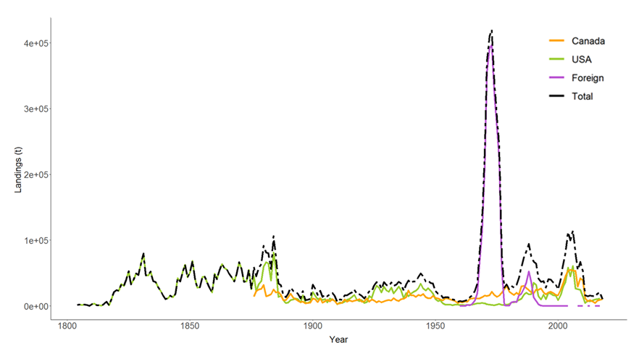

B

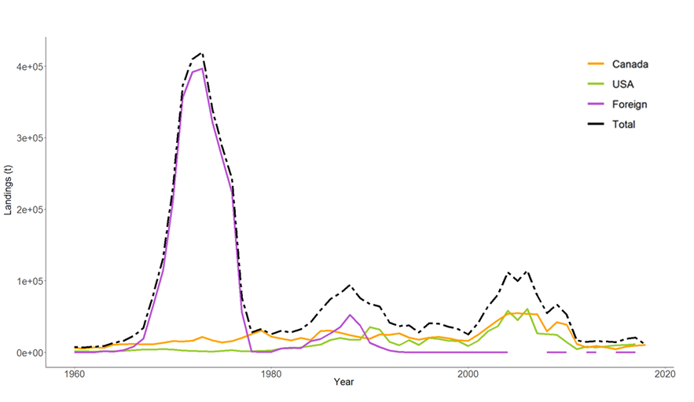

Figure S1. A) Atlantic mackerel catches (t) in the Northwest Atlantic since 1804 and B) since 1960.

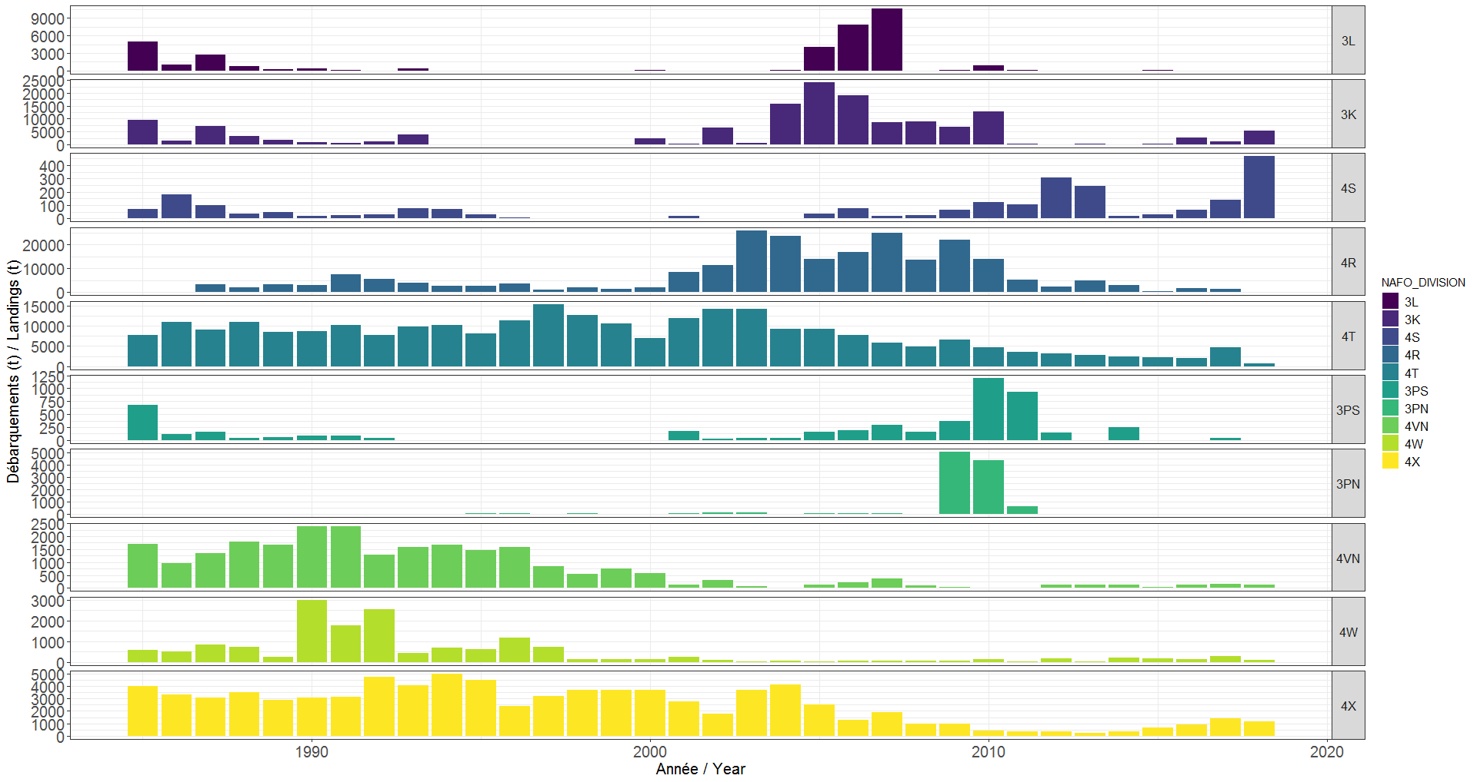

Figure S2. Landings by NAFO Divisions from 1985-2018. Scale varies among NAFO Divisions.

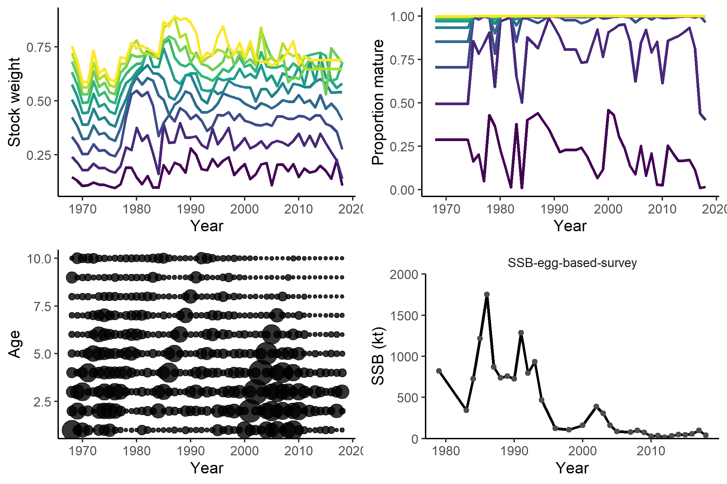

Figure S3. Stock weight (left panel) and proportion mature (right panel, ages 1 to 10+) data. Used deterministically within the assessment model to transform abundances to biomass.

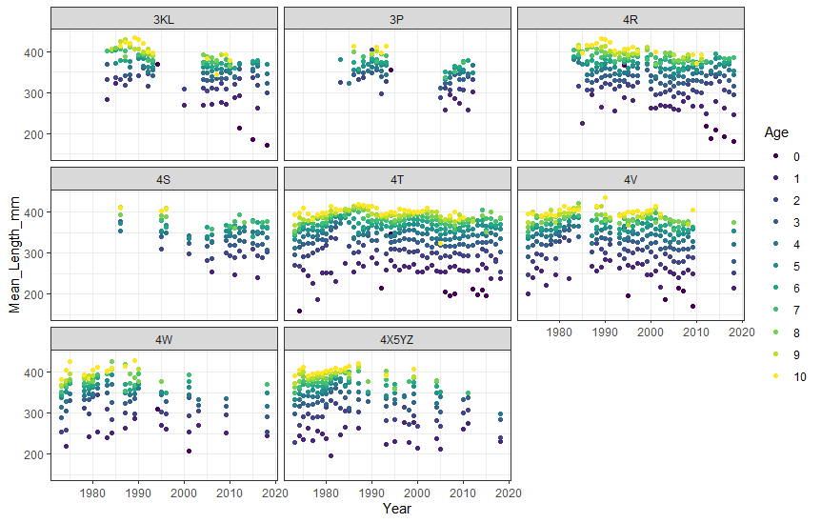

Figure S4: Mean length-at-age from commercial samples from NAFO subareas 3-4 from 1973-2018.

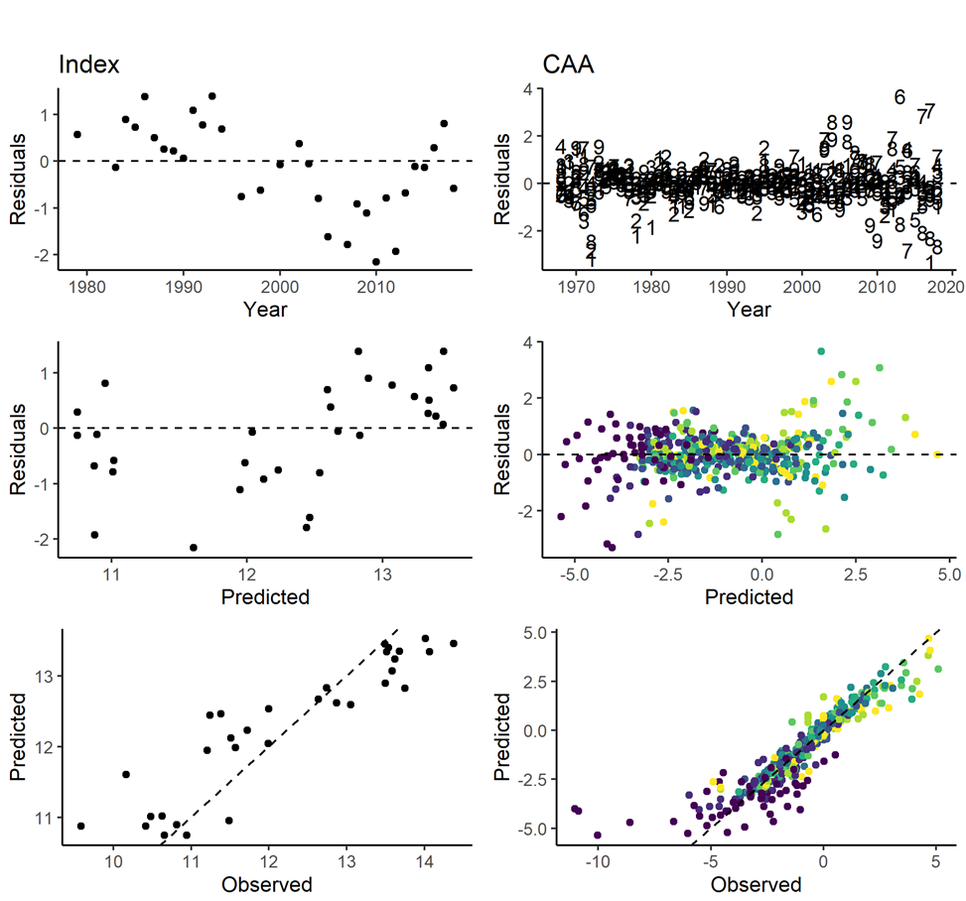

Figure S5: Model residuals. The color scale indicates the age classes (young to old as violet to yellow).

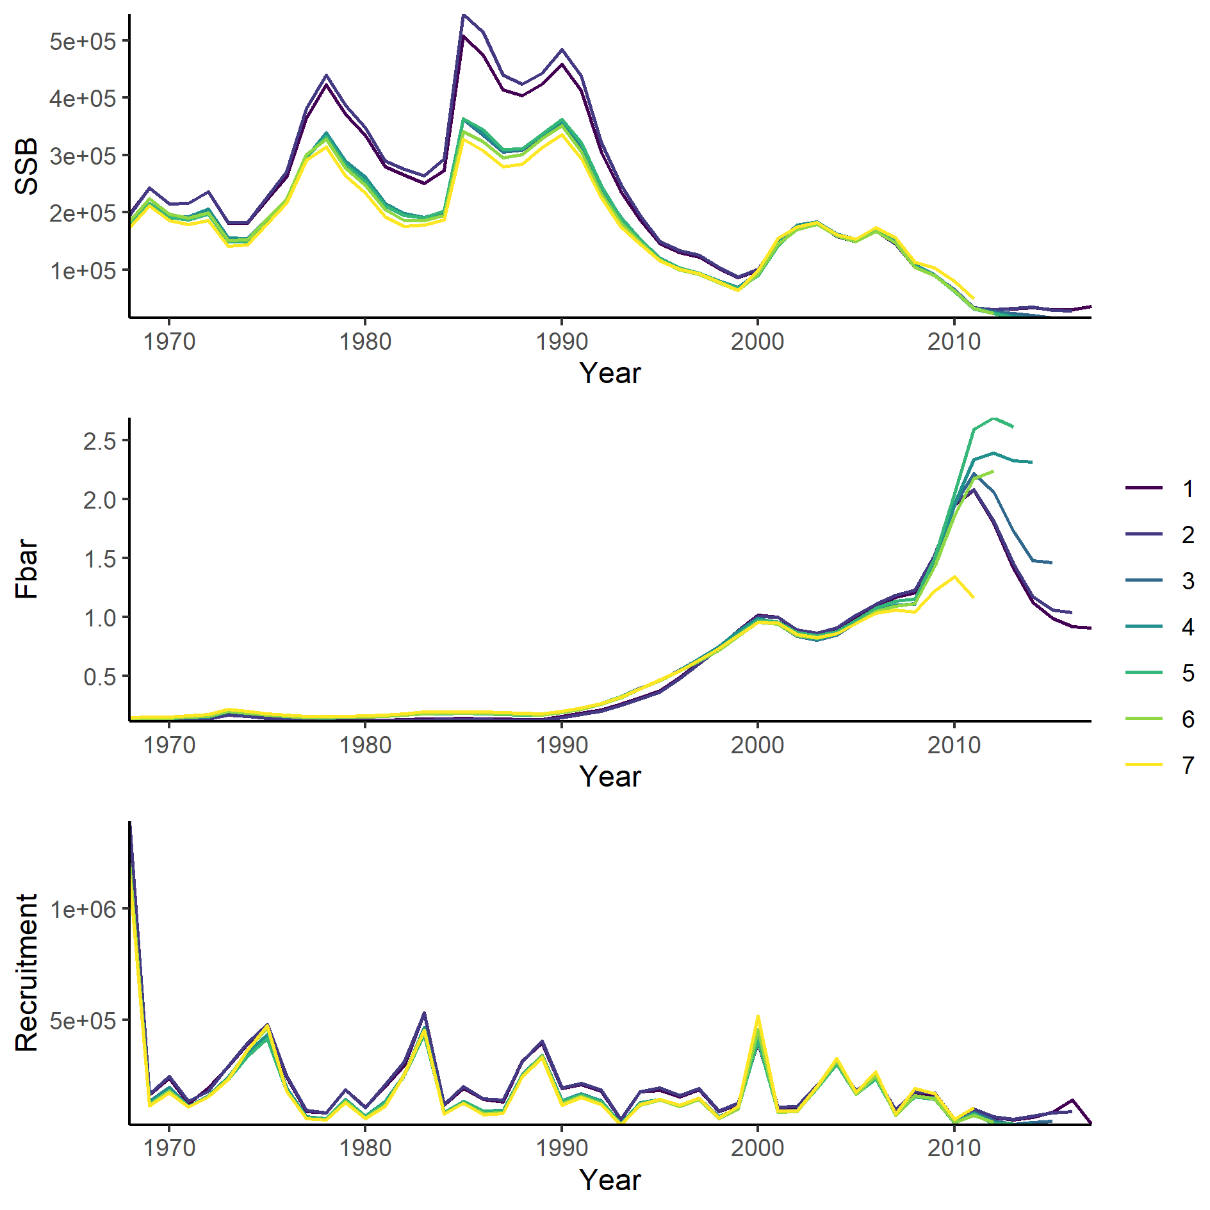

Figure S6: Retrospective patterns (Fbar = F over aged fully recruited to the fishery, i.e., ages 5-10).

|  |  |
| --- | --- |
| Recruitment (2001-2016) | Figure S7 - Recruitment (2001-2016) |
| Gain in condition (4R) | Figure S7 - Gain in condition (4R) |
| Gain in condition (4T) | Figure S7 - Gain in condition (4T) |

Figure S7: Effects plots of retained generalised additive models. Only models including both biological and physical variables are shown (see Tables S12-S14 for variable and model details).

|  |  |
| --- | --- |
| % Landings in 4R | Figure S7 - % Landings in 4R |
| % Landings in 3K | Figure S7 - % Landings in 3K |
| % Landings in 3L | Figure S7 - % Landings in 3L |

Figure S7 (suite): Effects plots of retained generalised additive models. Only models including both biological and physical variables are shown (see Tables S12-S14 for variable and model details).